Collaborative Work Management in ServiceNow
Guided Practice for Maximizing Collaboration and Task Management

Introduction
ServiceNow's Collaborative Work Management (CWM) is a solution designed to optimize teamwork, centralize tasks, and facilitate efficient collaboration between cross-functional teams. This series of exercises is designed to help you master the main features of CWM, allowing you to get the most out of this tool in your professional day-to-day work.

Exercise 1: Creating a Collaborative Space
A Collaborative Space is a personalized virtual environment where teams can organize, share, and track activities and documents related to a common goal. In it, members have centralized access to Task Boards and relevant Documents , promoting transparent and efficient communication. This space facilitates collaboration between different teams, ensuring that everyone is aligned on responsibilities, deadlines, and established goals, making the management of collective work more dynamic and productive.
- Objective: Learn how to create and configure a new collaborative space.
- Steps:
  - Access ServiceNow Collaborative Work Management through the Spaces menu. The name of the CWM Space is Collaborative Work Management
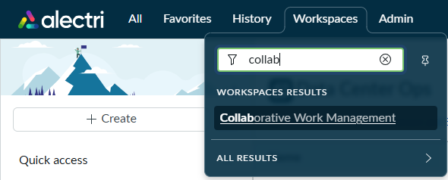
  - Click the Create button and select New Space
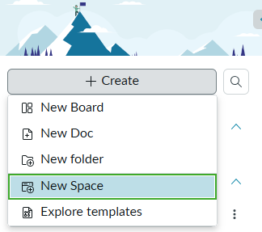
  - Give your new Collaborative Space a name and click the Create button
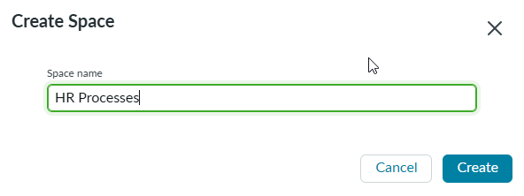
  - Click the Share this space link to invite people or groups to work with you in this space.
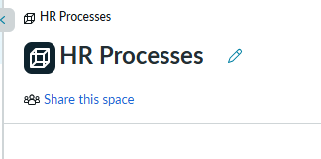
  - Select the people and/or groups of people who will work with you in this space.
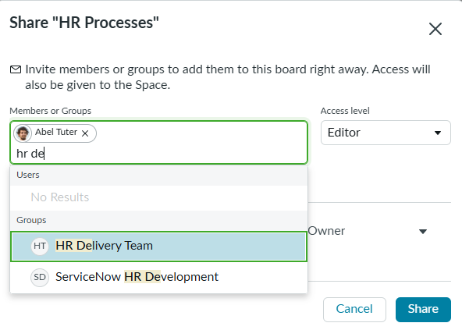
  - Select the desired Access Level and click the Share button.
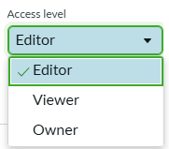
Editor: People who can work together with you in this space
Viewer: People who can access this space only to View information
Owner: People who will be Administrators of this space and can delete boards, columns, and docs.
  - Click the Create Board button to create your first Task Board
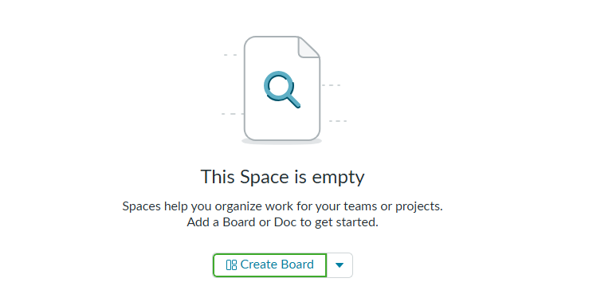
Note: You can also create frames using the + Create button in the left navigation menu or by using the Create button in the upper right corner
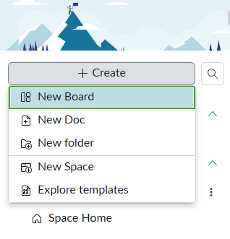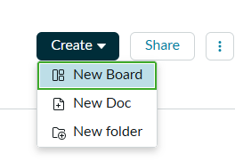
  - Enter the name of the board, and – optionally – click the Use templates link to select a collaborative board template.
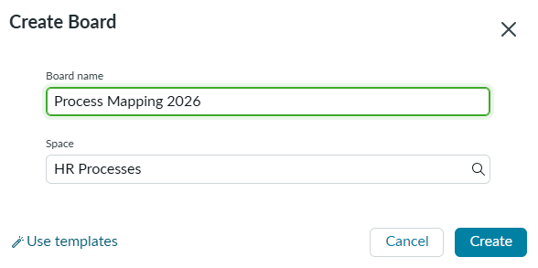
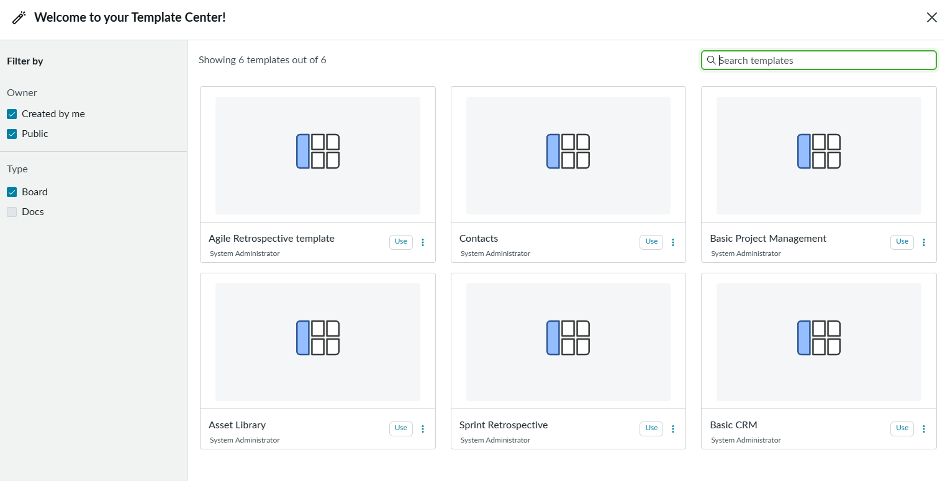
Note: You can also apply a template after the frame is created, using the context menu  in the upper right corner or the context menu next to the frame name in the Left navigation menu. Applying a template to a board with existing data will append the tasks to the bottom of the task list.
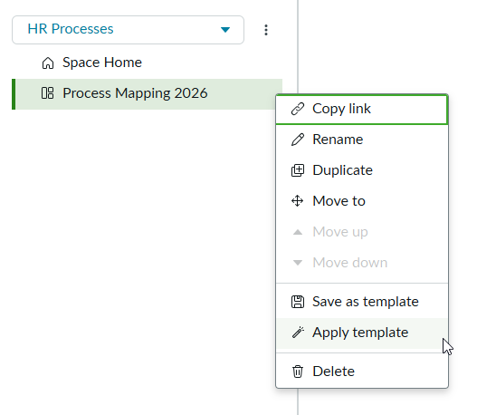
  - Click the Edit Board Details button  to open a side panel with your board details. You can fill in additional important information like Description, Assignment Group, Department, Strategic Program, Product, and Primary Objective. Other fields can be added by the system administrator if necessary.
Once you've filled in the information, use the Update button to save your changes.
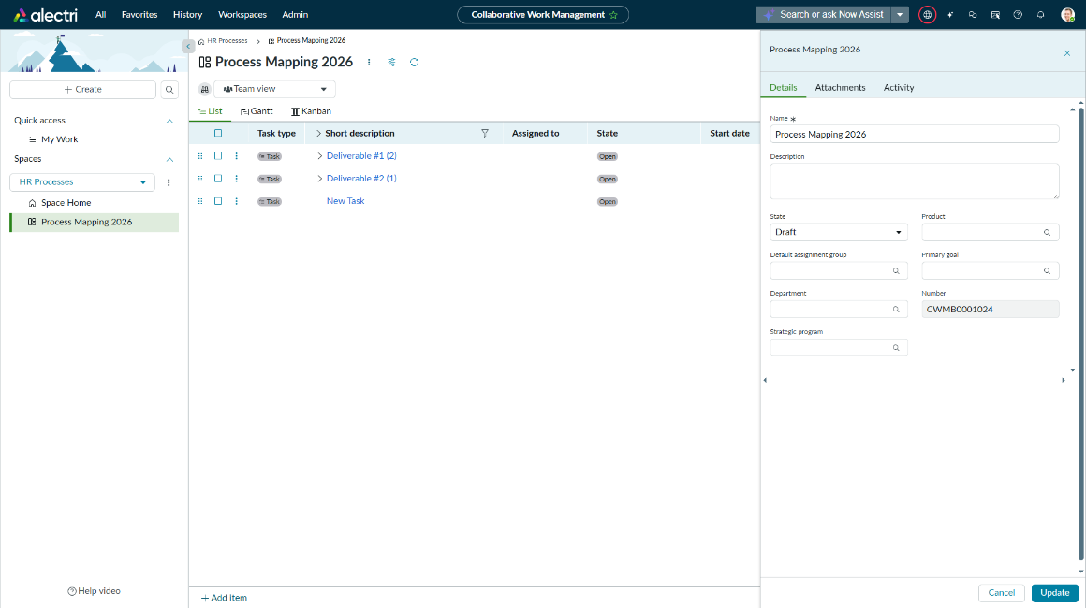
Congratulations, you've created your first collaborative space and your first task board!!

Exercise 2: Task Management

The management of tasks on a collaborative board can be done through different types of display available. By default you will see three views (List, Gantt, and Kanban), with a fourth view available (Sprint planning). You can enable or disable the displays using the Customize button  in the right sidebar.

In addition, in the list view you will be able to create new columns for your tasks without having to call an administrator.
- Objective: Add tasks, assign tasks, and track the progress of work.
- Steps:
  - Add a new task called "Format Document." To add a task you can use the Add Item button 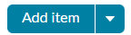 or the context menu of existing tasks, Add Item Above or Add Item Below items. To add a subtask, use Add Child Item. 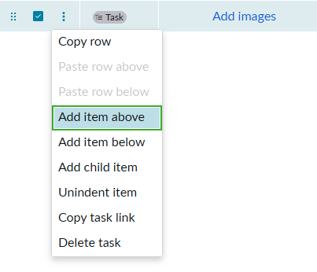
  - When you add the task name and press <ENTER> ServiceNow automatically opens a new row, so you can continue adding as many tasks as you want. Add three more tasks: "Create Form," "Validate Form," and "Publish Form." Then press <ESC> to stop adding tasks.
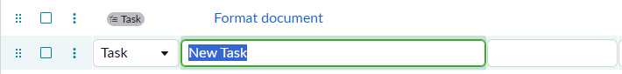
  - To rearrange tasks, use the Rearrange Row button to drag the row and drop it into the correct position.

  - The row context menu can also be used to Indent Item (turn a task into a subtask) or Unindent Item (turn a subtask into a task).
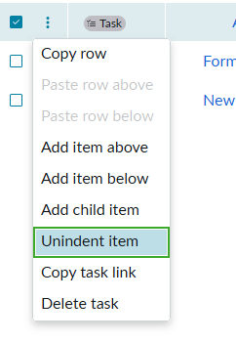
  - To perform a multitask action, select the desired tasks using the corresponding Checkbox and trigger the context menu, or use the Rearrange button on any of the selected tasks. All selected tasks will be subject to the same action.
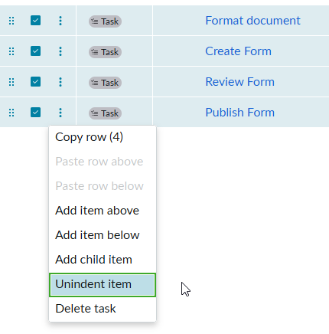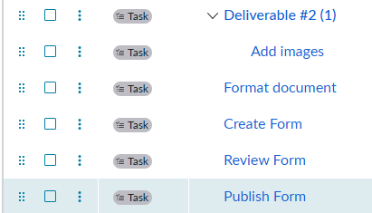

  - Determine the person responsible for each task using the Assigned To column (to edit the information, double-click on the mouse)
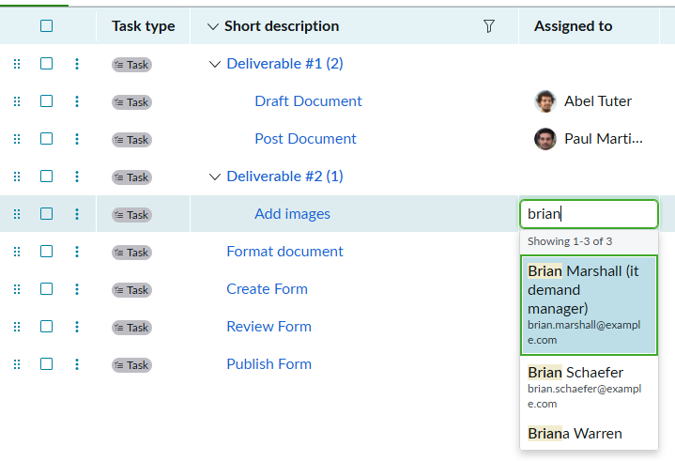
  - If you select a person who doesn't already have access to the Space, you'll receive a warning and you can either Grant access immediately or not.
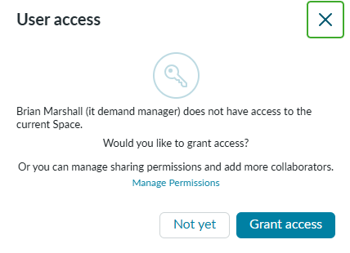
  - To edit multiple tasks with the same information, select the corresponding field in each row by holding <CTRL> (or <COMMAND> on Mac). Double-click on one of them and enter the desired value. All selected rows will change in the same way.
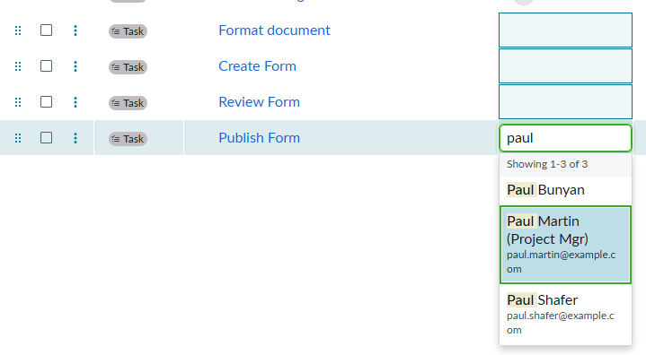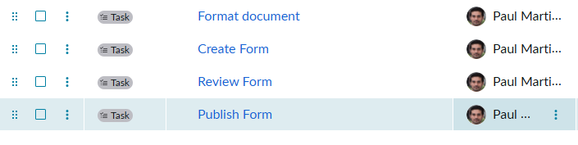
  - Now let's set up the list to add other columns. Click the Customize button . In the Available columns section, use the filter to find and select the following columns:
    - List of additional assignees
    - Priority
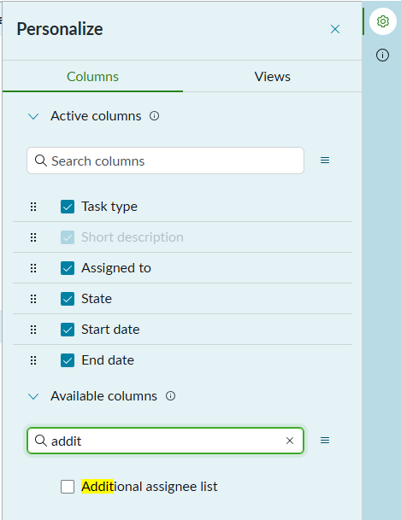
  - Use the drag button to position the columns as shown in the following image, and then close the Customize panel using the close button 
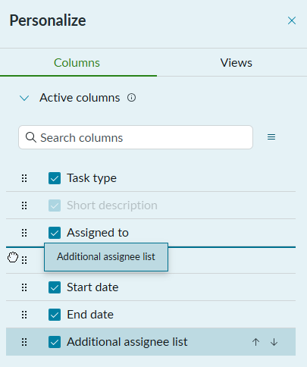
  - To avoid losing the new layout, use the Save View button 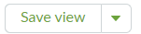 and choose the Save to Current View option. Each time you make changes to the layout (such as changing column width, column order, adding columns, or adding filters), you will need to save the changes.
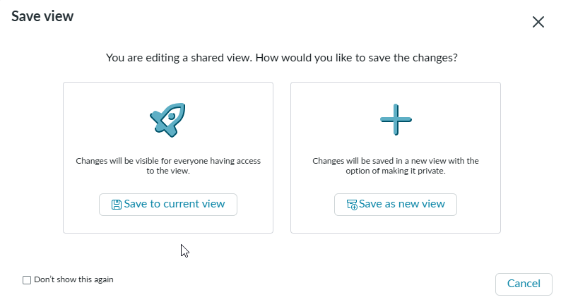
  - Set due dates and priorities for each task.
Now we need to include new information that is not yet available in the system's default table. Let's include a column to indicate the Approver for the task, another to indicate the Approval Status, and one to indicate the Approval Date.
  - Click + Add Column in the list header (you may need to scroll to the right) and select the People type
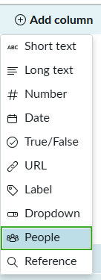

  - Fill in the Field Name as Approver and User Type as Users in this space. Then click the Add Column button.
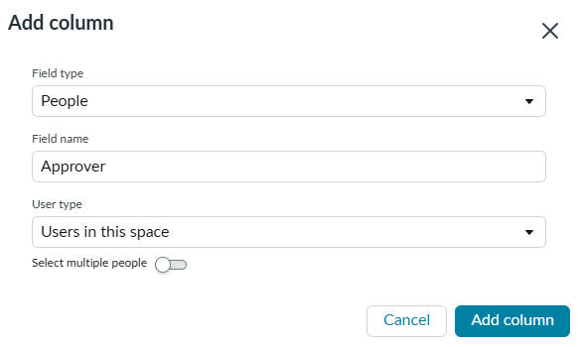
  - Click + Add Column in the list header and select the Date type . Fill in the Field Name as Approval Date and click the Add Column button.
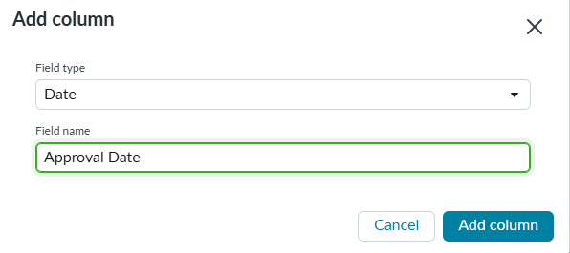
  - Click + Add Column in the list header and select the Label type. Fill in the Field Name as Approval Status . Add the options as shown in the following figure, and then click the Add Column button.
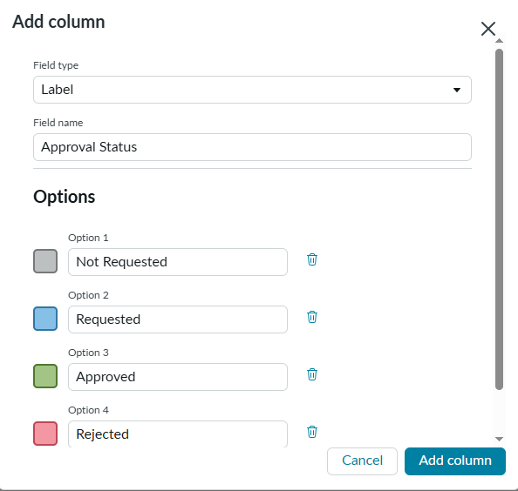
  - Click the context menu of the Additional Assignee List column and select Hide this column.
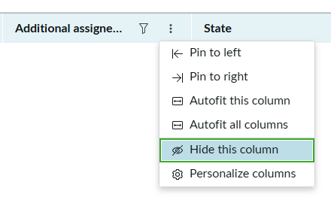
  - Also hide the Status, Priority, Start Date, and End Date columns. Your list should look like the following:
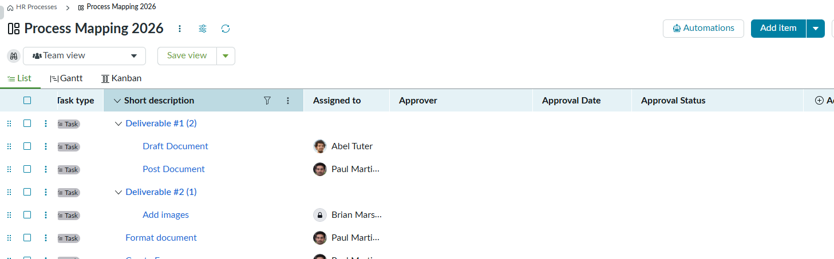
  - Click the Save View button 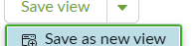 and choose the Save as New View option. On the Create View screen, enter the name of the new view Approval. Select the Make this a shared view option and click the Create button.
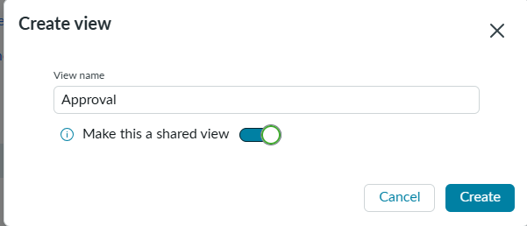
  - Use the Views selector to switch between the Team View and the Approval View
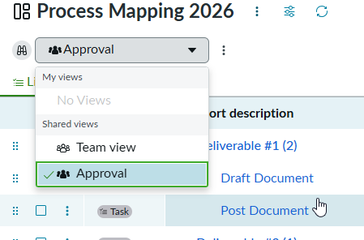
  - Test your new Approval fields.
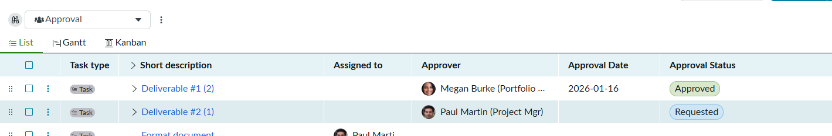
  - Set your Board Preferences by clicking the icon.
  - Automatically hide items that have not recently been recently updated or hide completed items. Click Apply to save changes. These settings will be applicable across all board views.
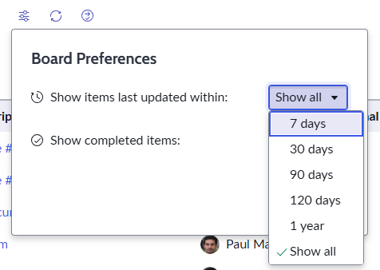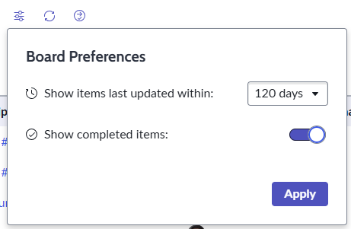
  - From the Team View, add dates and then see how your board looks with Gantt
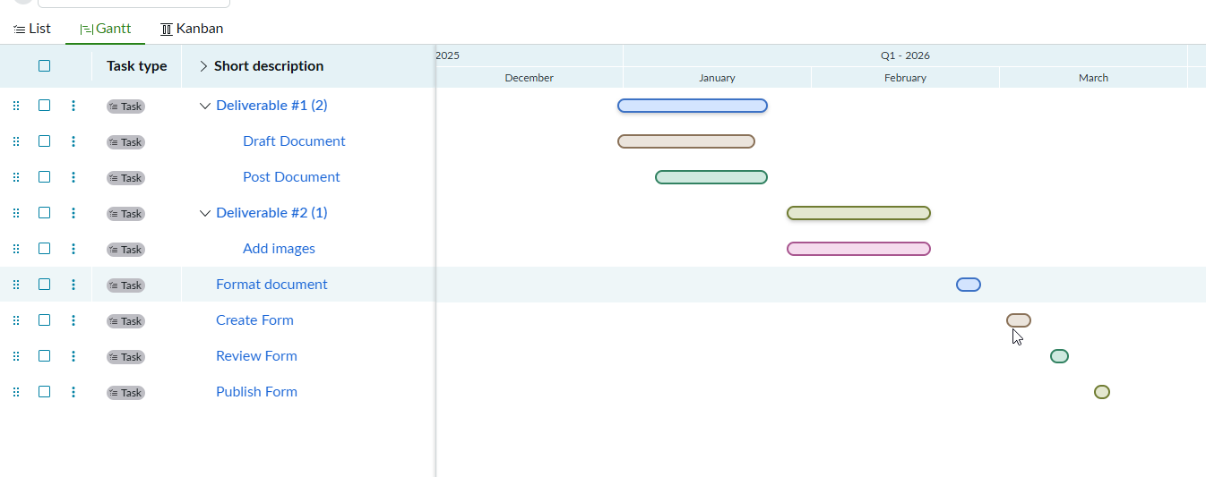
  - Switch the Kanban tab and click the gear icon to select which fields display on the card. Select Assigned to, State, and Story Points. Click Save View
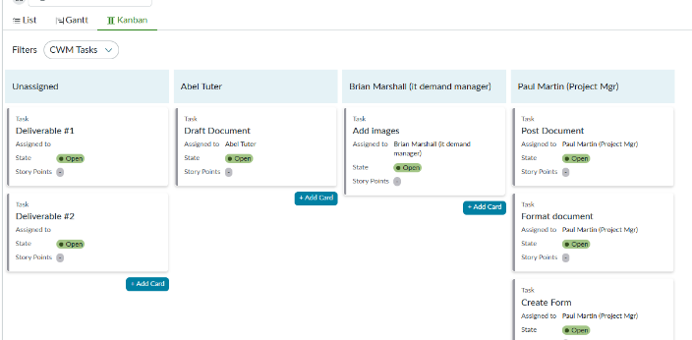
Note: in the Kanban View you can configure the Vertical and Horizontal Swimlanes using the Customize button
Congratulations, you've assigned tasks, created new columns, and set up views on your task board!!

Exercise 3: Creating a Document and Organizing Your Space
- Objective: Create a document in CWM using a document template
- Steps:
  - Click the Create button and select New Document
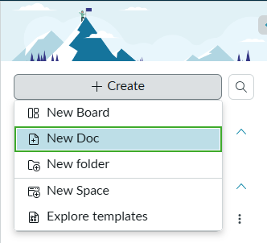
  - Click the Create button and select New Document. Enter the Document Name and – optionally – use the Use Templates link to choose a document template.
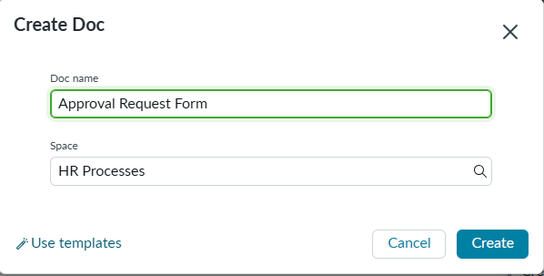
  - To enter a person's name, you can use the @ symbol and search for the person's name in the list
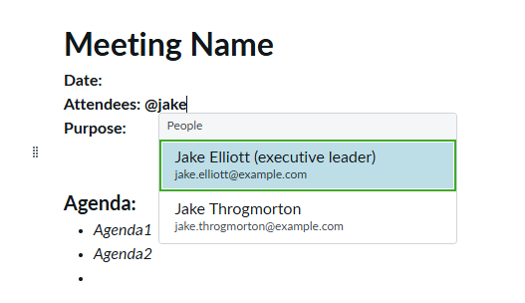
  - Use the / menu to access other options.
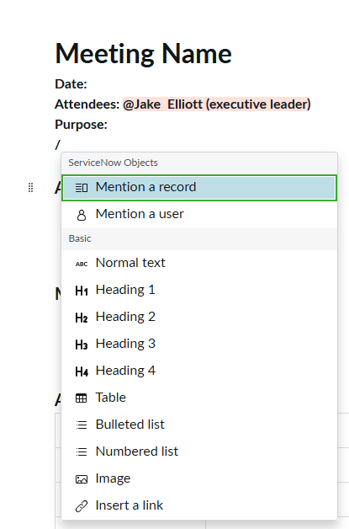
  - The Mention a record option allows you to insert a link to a ServiceNow object (a task, project, incident, etc.). The available options are configured by the system administrator.
    - Search for the object type (CWM Tasks) and the specific record
    - Click on the record to add a reference to that object
    - Hover over the reference to see up to date details
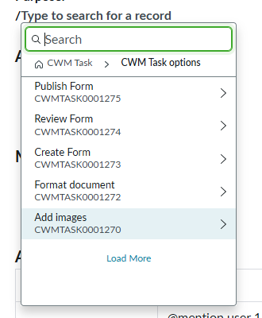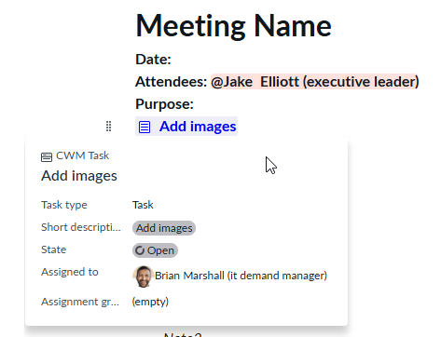
  - To add related details directly into the document, search for the record and then click the arrow icon 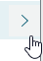 to select fields.
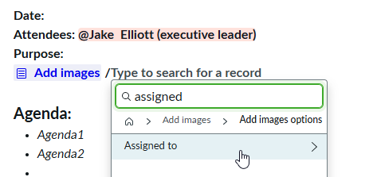
  - The context menu in the Pages list on the left brings options such as Create Subpage, Duplicate Page, Apply Template, and Save as Template.
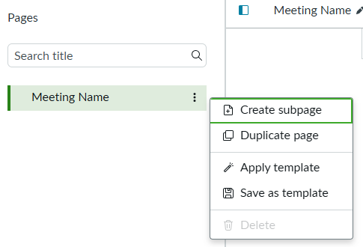
  - The context menu in the upper right corner of the screen brings options such as Apply Template, Save as Template, and Export as PDF.
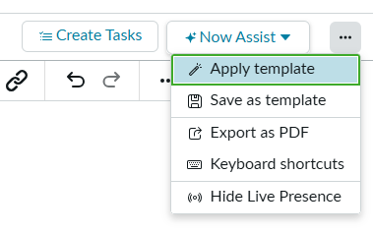
  - Click Create Tasks to generate tasks from the document and add them to a Board
  - Click Now Assist or highlight a section to use generative AI to summarize or rewrite the document
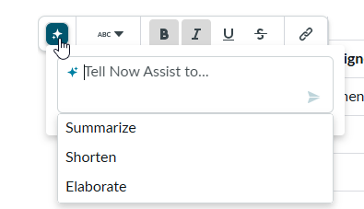
  - The + Create button also allows you to create Folders to organize your Boards and Documents.
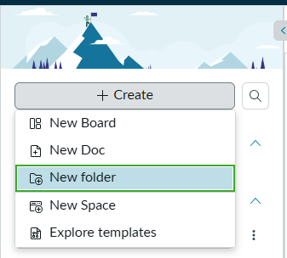
  - The context menu next to each item in the space brings options such as Copy Link, Rename, Duplicate, Move To, Move Up, Move Down. 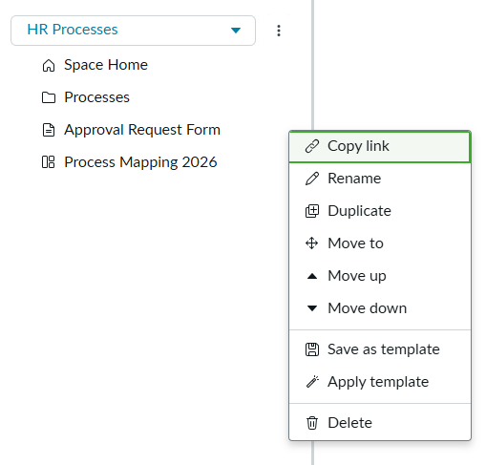
  - Use Move To to move a document or board to other spaces or within a folder.
Congratulations, you created a Document using a Template, created a Folder and reorganized your Collaborative Space!!

Exercise 4: Manage your tasks with My Work

As a participant in one or more Collaborative Spaces, you may have activities on multiple boards. To make your work easier, CWM offers the My Work option, so you can centrally see all the tasks that are assigned to you, on all boards of all spaces, as well as any work from SPM or Connected Work items.
- Objective: Manage your activities, regardless of the frame or source of work.
- Steps:
  - Click on the My Work link
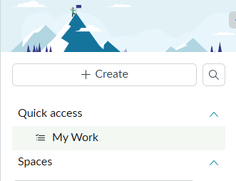
  - You'll see a Dashboard with your tasks by State and by Priority. Use the Item Type and Date filters to filter your tasks.
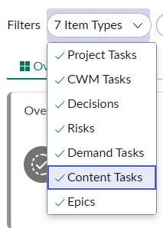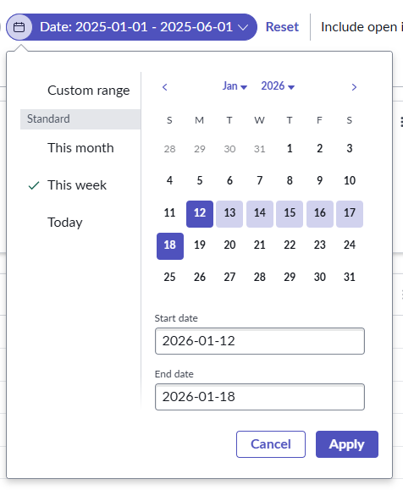
  - After filtering the records, the Dashboard updates according to the options you select. Click on dashboard widgets or the List tab  to see your activities.
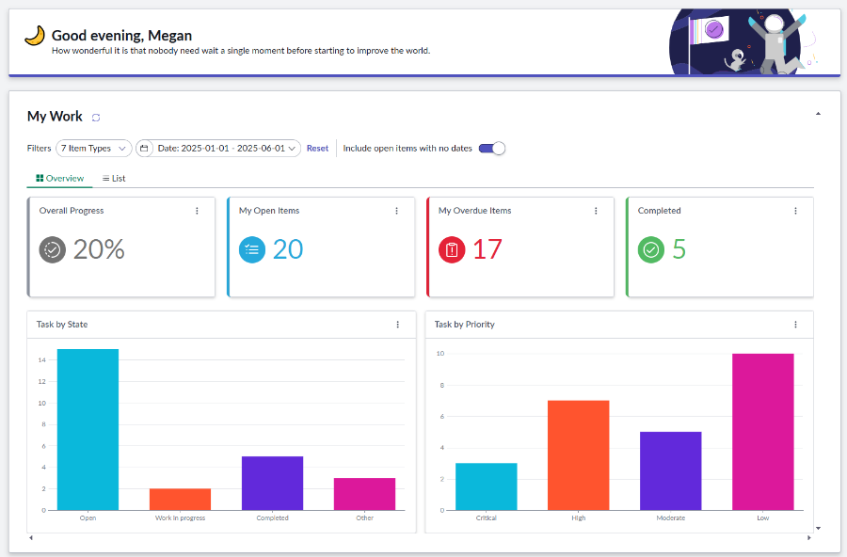
  - You can sort your activity list by Date, Priority, or any other column by clicking the corresponding column header. To record the progress of a task you can click on the link on the left side. To navigate to the source of that task (a CWM Board, a Demand, a Project, etc.) click on the link on the right side
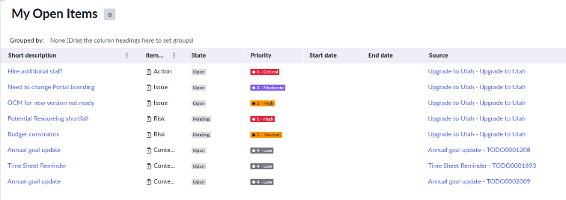
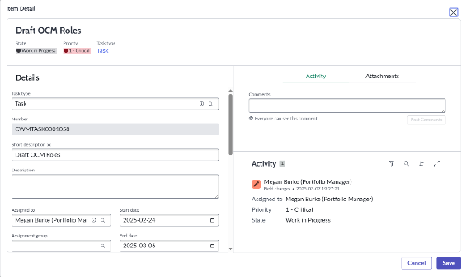
Congratulations, you have seen all your tasks at once using the My Work function!!

Exercise 5: Automations

You can Automate some simple actions or notifications by using the Automations button 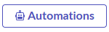.
- Objective: Create automations to notify people about tasks
- Steps:
  - Click the Automations button .
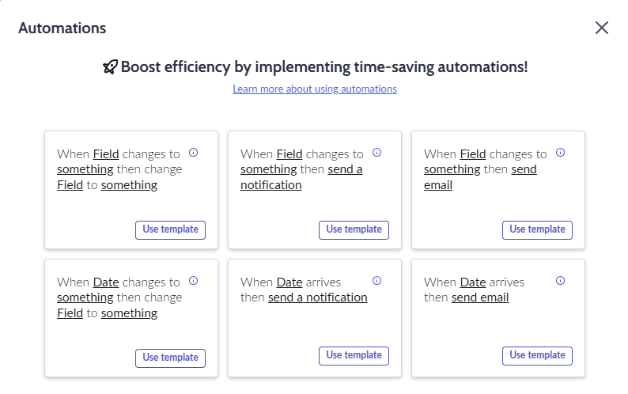
  - Select the template When Date arrives, send email by clicking the Use Template button.
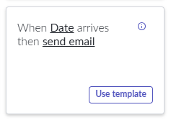
  - Set up the Automation as in the following figure and click the Add Automation button to save.
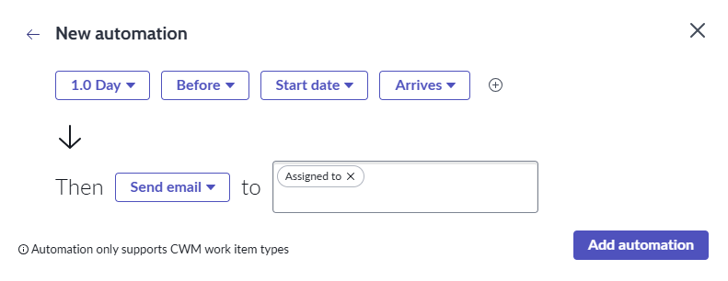
  - Click the New Automation button and let's set up a second rule
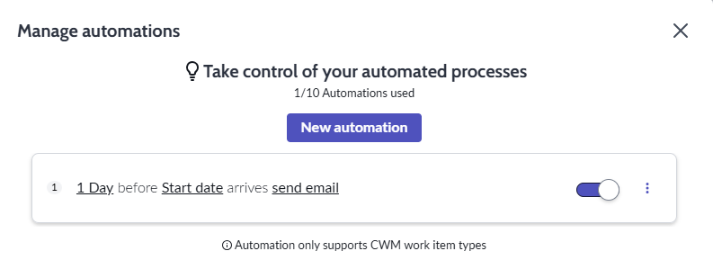
  - Select the template When Field changes to something, send email by clicking the Use Template button
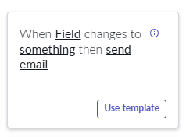
  - Set up the Automation as in the following figure and click the Add Automation button to save.
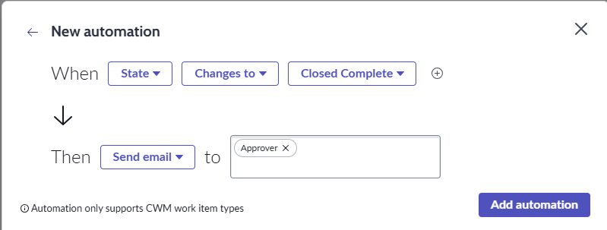
  - Close the Automations screen using the close button
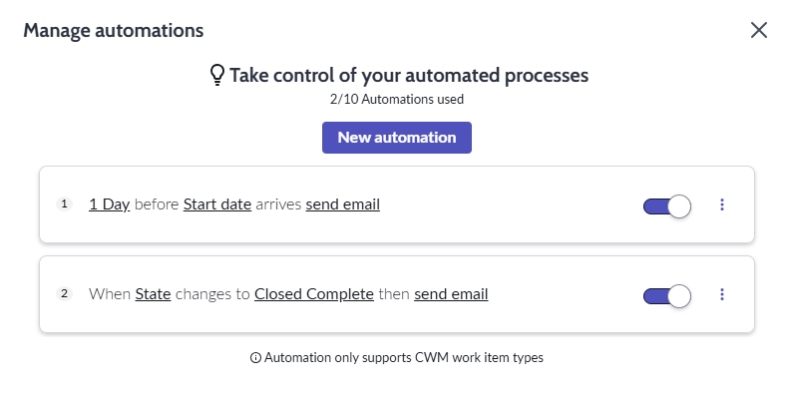
Congratulations, you have automated two notification rules on your Activity Board!!

Exercise 6: Connect Other Work
The Connect Work enables team to import other types of work that are assigned to their team directly into CWM, giving them a single place to view all of their work.
- Objective: <update.
- Steps:
  - From the related actions menu off the Board header, click Connected Work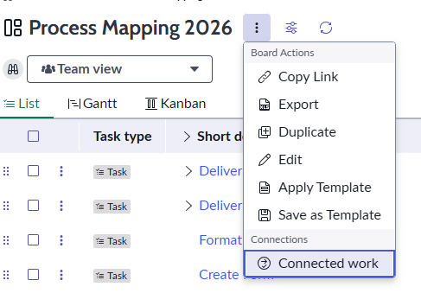
  - Click + Add New
  - Search for the table name that you want to add 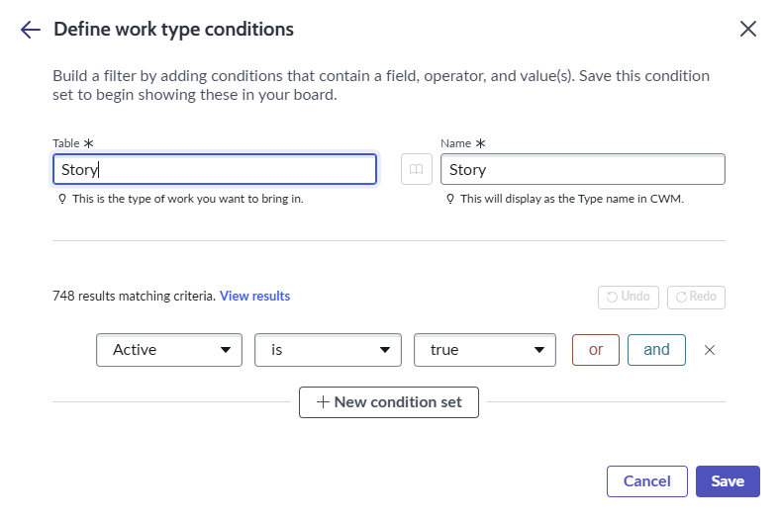
  - Click and to add more conditions for which records will be imported, such as by Assignment Group or Sprints. Notice the number of results matching the criteria will automatically update. 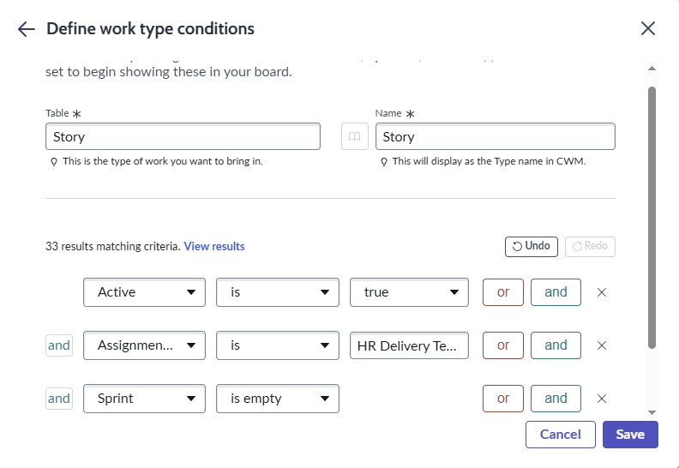
  - Click Save
  - Click +Add New to add additional connected work types or click Save to exit. 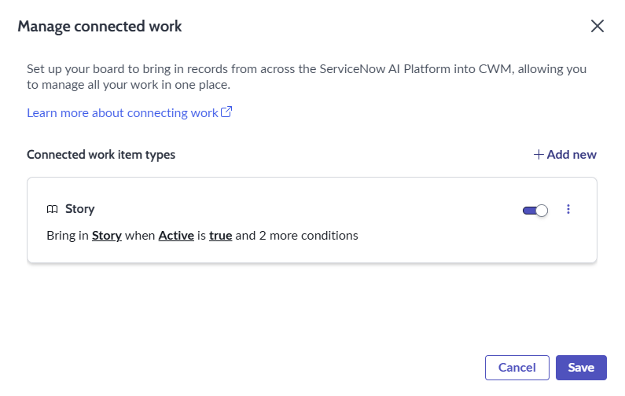
  - The items meeting the criteria will be dynamically added to the board.
  - To view details and make changes to connected work items, click on the short description on the List tab to open up the side panel view. 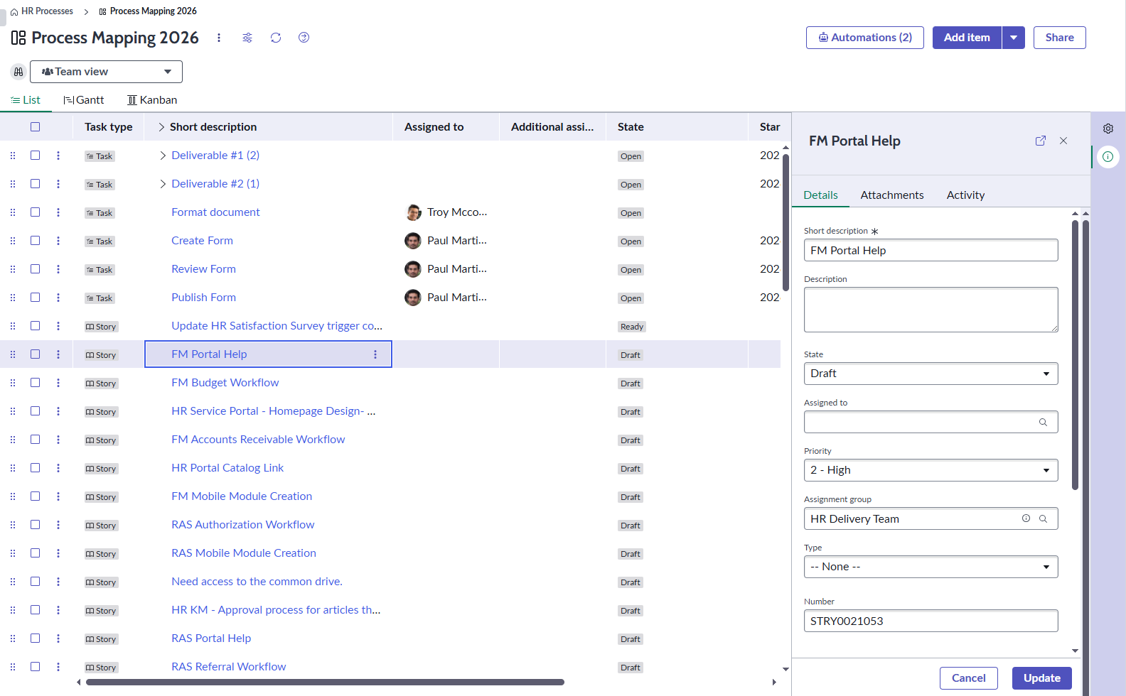
Congratulations, you can now manage all your teams work in one board!!

Exercise 7: Manage Work in Sprints
Agile teams can manage their work, regardless of type, in CWM. From the Sprint Planning view, teams can create sprints, manage their backlog, and balance their workload across planned and operational work.
- Objective: Create and manage sprints, assign story points, and create a sprint retrospective.
- Steps:
  - Click the gear icon and then select the Views tab.
  - Check the box next to Sprint Planning 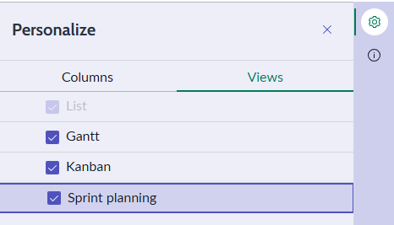
  - Click over to the Sprint Planning tab
  - To create a new sprint, enter the sprint name, duration, story points capacity, and start and end dates. 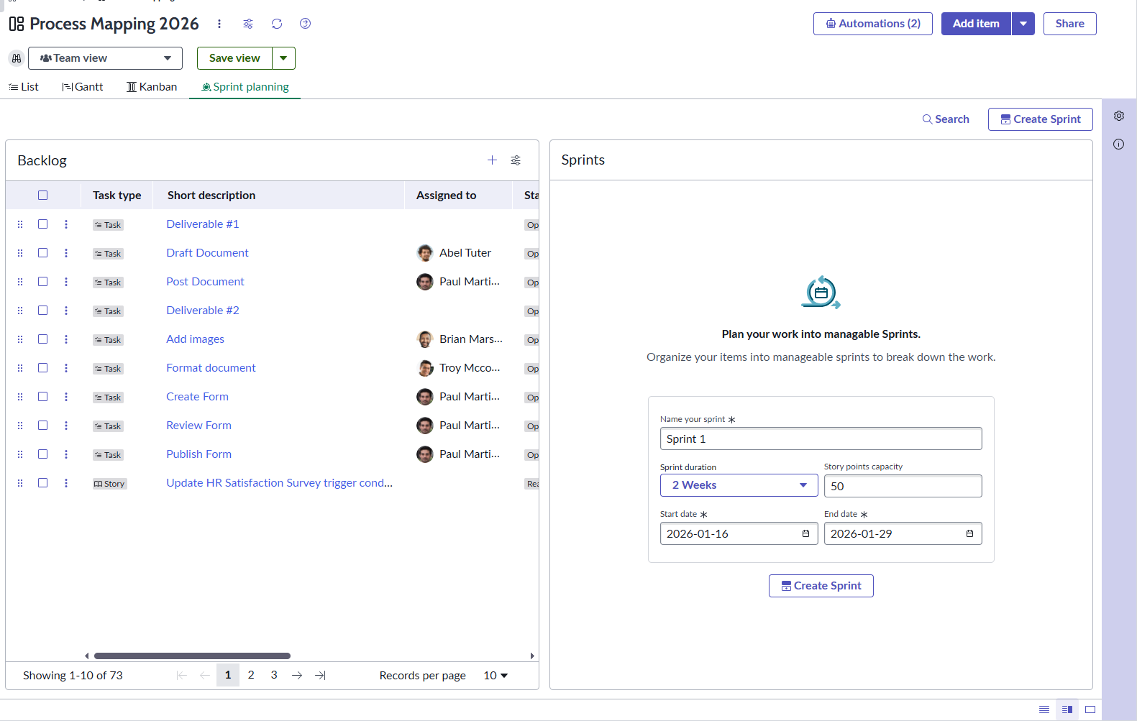
  - Click Create Sprint
  - To create additional sprints, click Add another sprint 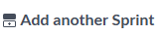. The next sprint be named with the consecutive number and will have the same duration and capacity.
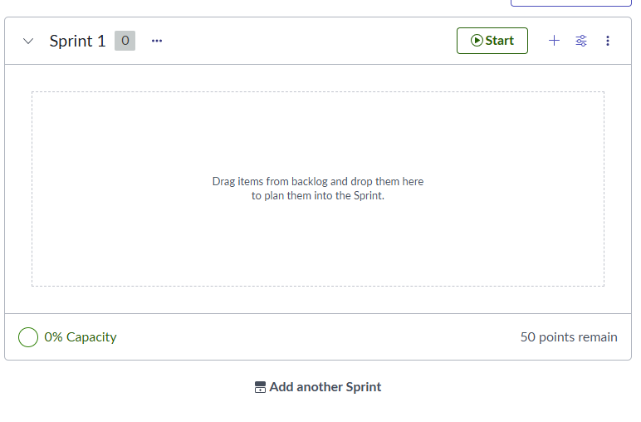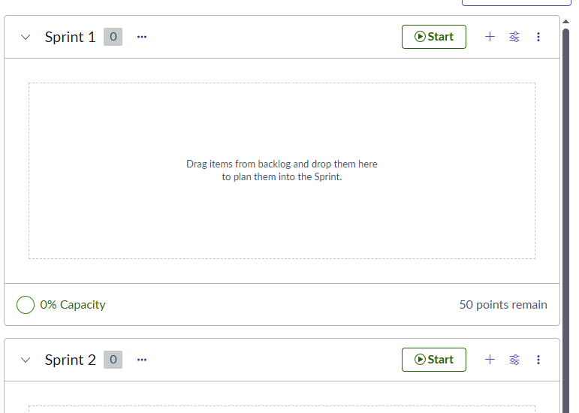
  - From the bottom right of the screen , toggle between backlog only, split, or sprint only layouts.
  - Add story points and drag items to rank them in the Backlog 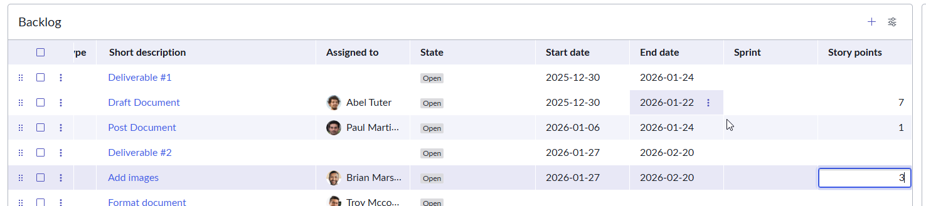 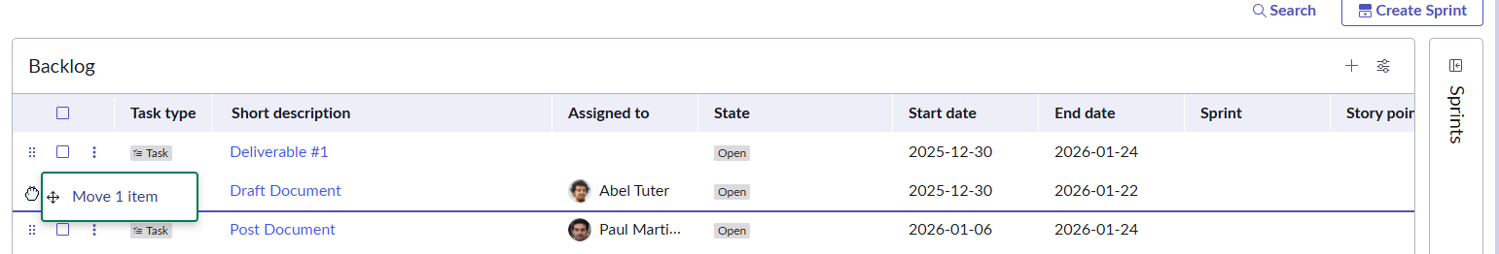
  - Click the icon to re-open the Sprints drawer from the right side of the screen. 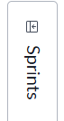
  - Select multiple items and drag them into sprints 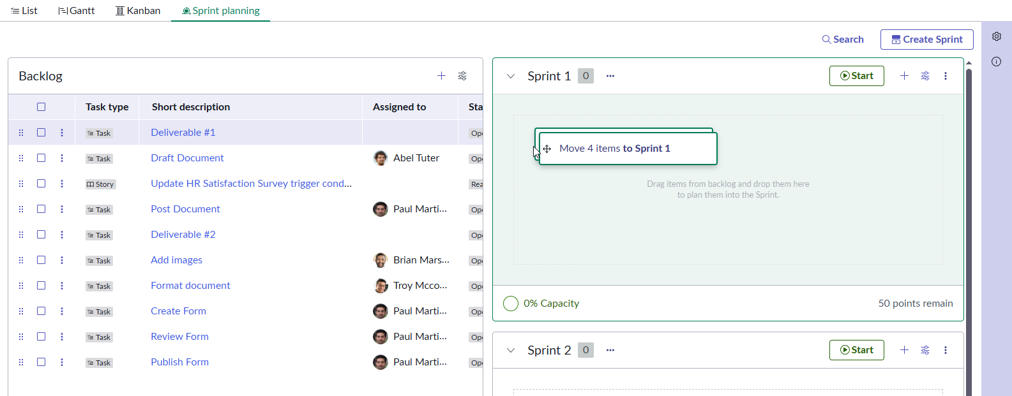
  - 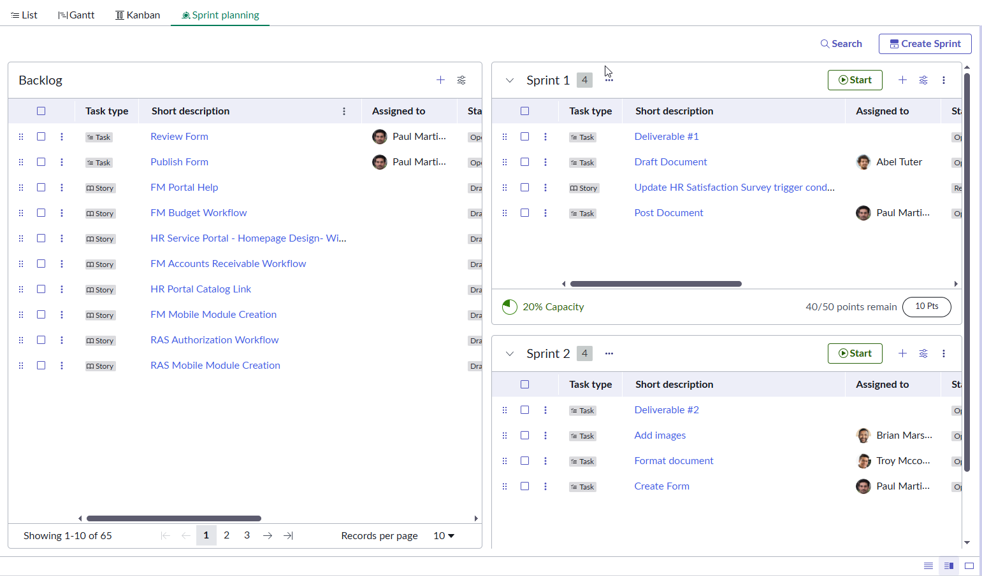
  - Click 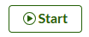to start the current sprint
  - Click 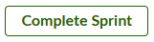 when the sprint is over. 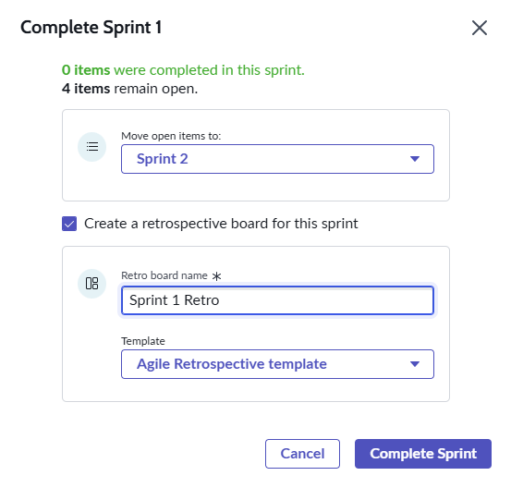
  - Choose to move open items to the next sprint or the backlog.
  - Check the box to create a retrospective board for the sprint. Name the board and select a template for the board. Click Complete Sprint
  - Navigate to the sprint retrospective board
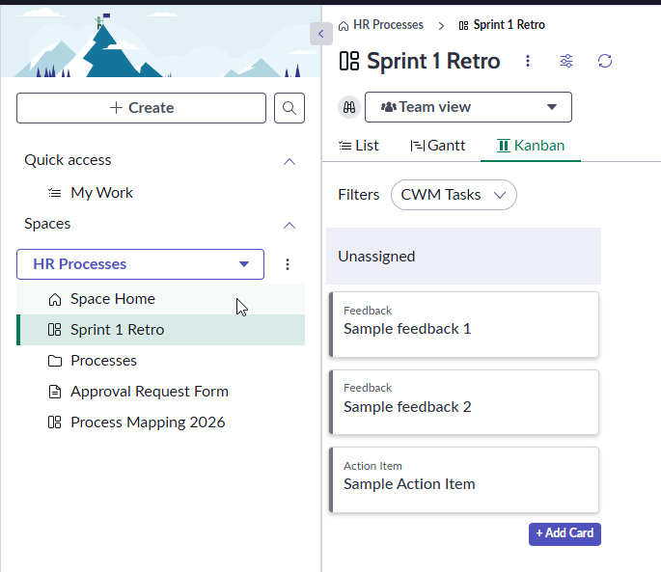

Congratulations, you have now created and managed your work in sprints!!
Congratulations, you have completed all the Exercises to get to know Collaborative Work Management better!!

