Well-known configuration URL :
Returns the OpenID Connect configuration values from the provider's Well-Known Configuration Endpoint, per the specification. For more details, click here
Sample Format :
https://{oauth-provider-hostname}/.well-known/openid-configuration
OpenID Connect provider information for Google.
https://accounts.google.com/.well-known/openid-configuration
- Visit https://console.developers.google.com and sign in with your Gmail credentials.
- Accept the terms and click 'AGREE AND CONTINUE'
- Click on 'CREATE PROJECT', provide a unique name and click on 'CREATE.
- After completing these steps, you will see below screen.
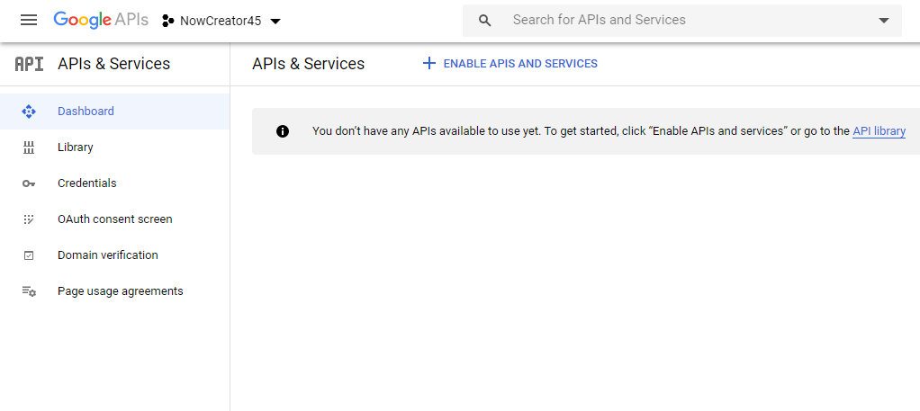
- Now, select 'Credentials' from menu options and Click on 'CREATE CREDENTIALS' and select OAuth client ID.
- To create an OAuth client ID, you must first set a product name on the consent screen. Click on CONFIGURE CONSENT SCREEN to proceed
- Select User Type as 'External' and click 'CREATE'.
- You will see OAuth consent screen, please fill out only Application name and keep other fields as it is for now. Click on Save to continue.
Application name: ServiceNow OIDC (Give any name you want)
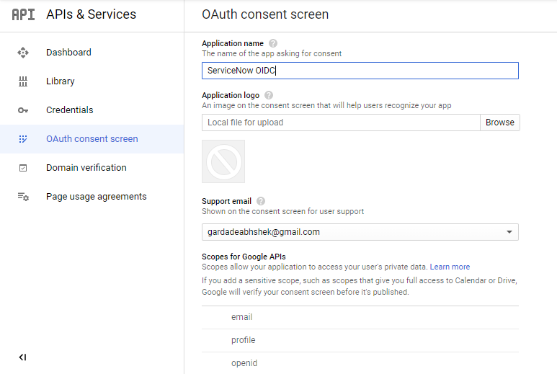
- Now we are ready to create Credentials. Navigate to Credentials and select 'OAuth client ID' under 'CREATE CREDENTIALS'
- Fill out the below details.
Application type: Web application
Name: provide any name you want.
Authorized JavaScript origins: Your instance URL
Authorized redirect URIs: Your instance URL
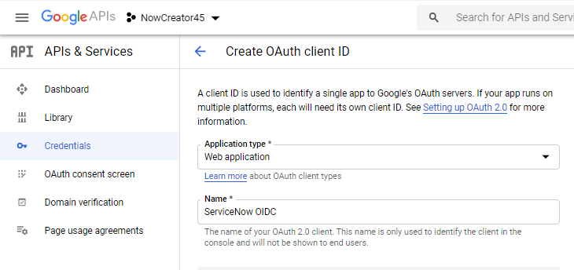
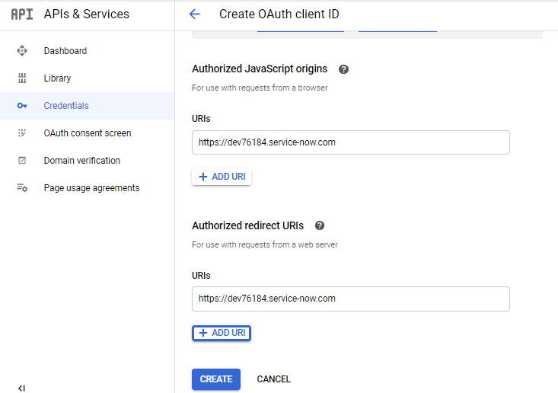

- Once Click on Create, you will see a window “OAuth Client created”
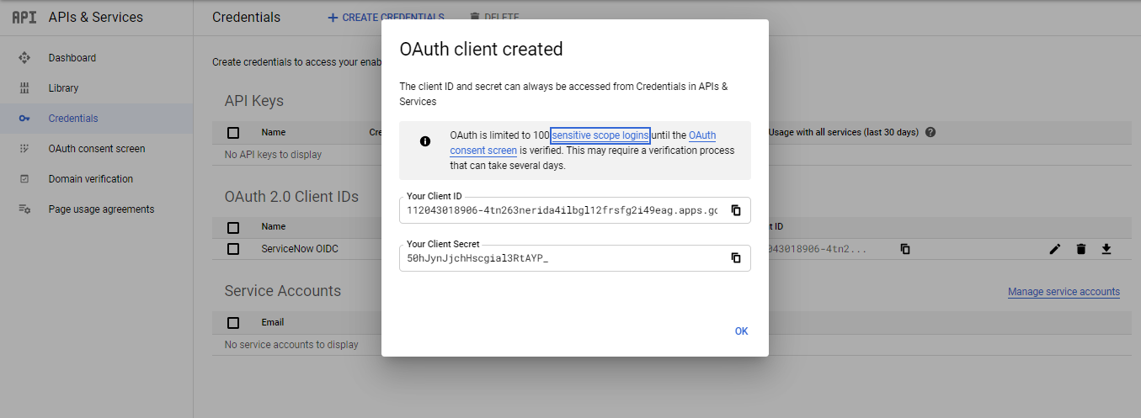
- You can note down the Client ID and Client Secret Details or you can download a file by clicking download Icon (marked in yellow).
- Now, we are ready to configure our ServiceNow instance.
References:
https://cloud.google.com/identity-platform/docs/web/oidc
https://cloud.google.com/anthos/gke/docs/on-prem/how-to/oidc

