New Incident Button on User Form

This is a sample logic to create,
- UI Action to create a button to Create New Incident
- Stay on the same page
- Display Related Incidents in the same sys_user form under related incident tab

UI Action ( script )

createIncident();
function createIncident() {
// Create an Incident record
// Populate the Caller, Short description, and Description fields with details from the NeedIt record
var grInc = new GlideRecord("incident");
// grInc.caller_id = current.u_requested_for;

// var usr = new GlideRecord('sys_user');
// if (usr.get('user_name', current.getValue('sys_created_by'))) {
// current.caller_id = usr.getValue('sys_id');
// }
var usr = new GlideRecord('sys_user');
if (usr.get('user_name', current.getValue('user_name'))) {
current.caller_id = usr.getValue('sys_id');
}
var caller = current.caller_id; //current.user_name.getRefRecord();
//Gets the sys_user GlideRecord for the caller
grInc.caller_id = caller; //current.user_name;
grInc.u_string_2 = current.phone;
grInc.short_description = "FIVE9 INCIDENT -" + current.user_name + "-" + current.first_name;
grInc.description = "Test request " + current.user_name + " requires some facilities work. " + caller;
grInc.insert(); // Add Incident to database

var sys_idd = grInc.getValue('sys_id');

// Add a Work note to the NeedIt record indicating an Incident was created
// Include the Incident Number in the Work note
current.short_description = "FIVE9 INCIDENT " + grInc.number + " " + current.user_name + caller;
current.description = "Test request " + grInc.number + " requires some facilities work. ";
current.work_notes = "Incident " + grInc.number + " created to for the incoming call - five9";
current.update(); // Update NeedIt record in database
}
action.setRedirectURL(current);

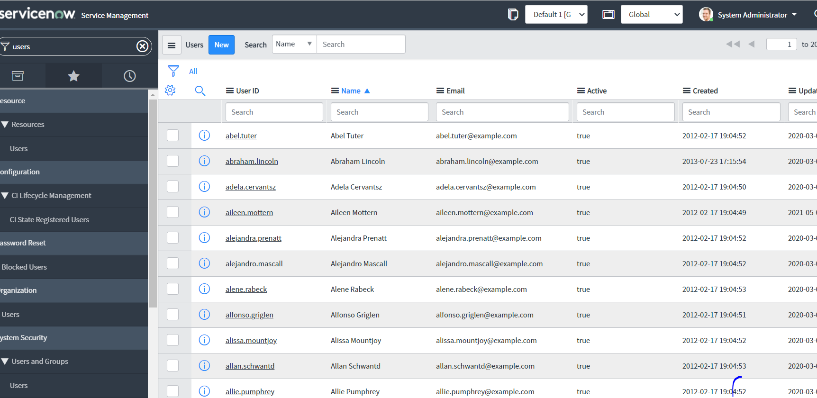

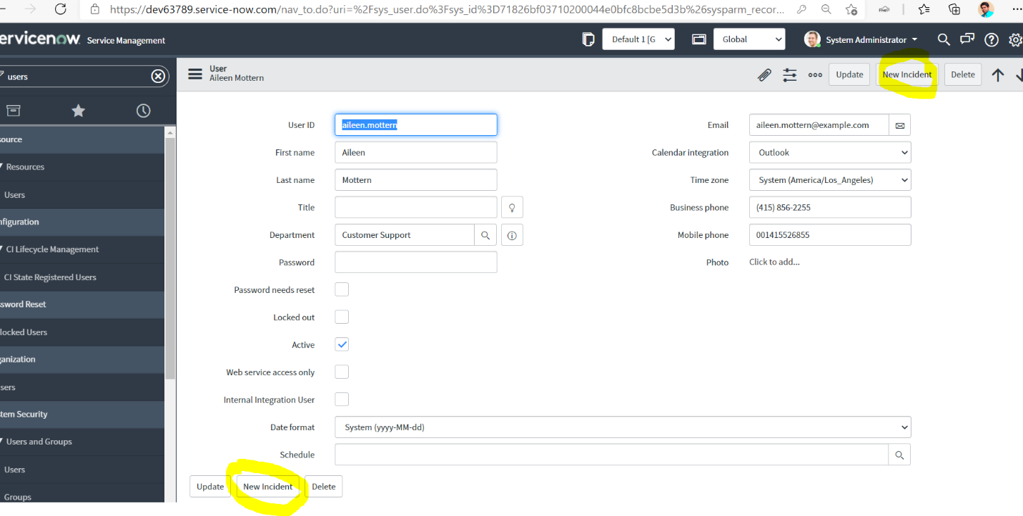

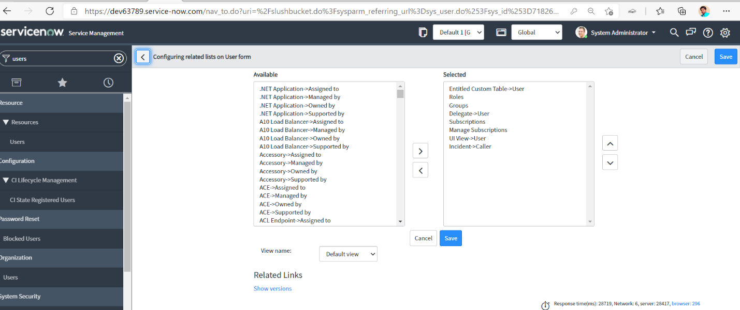

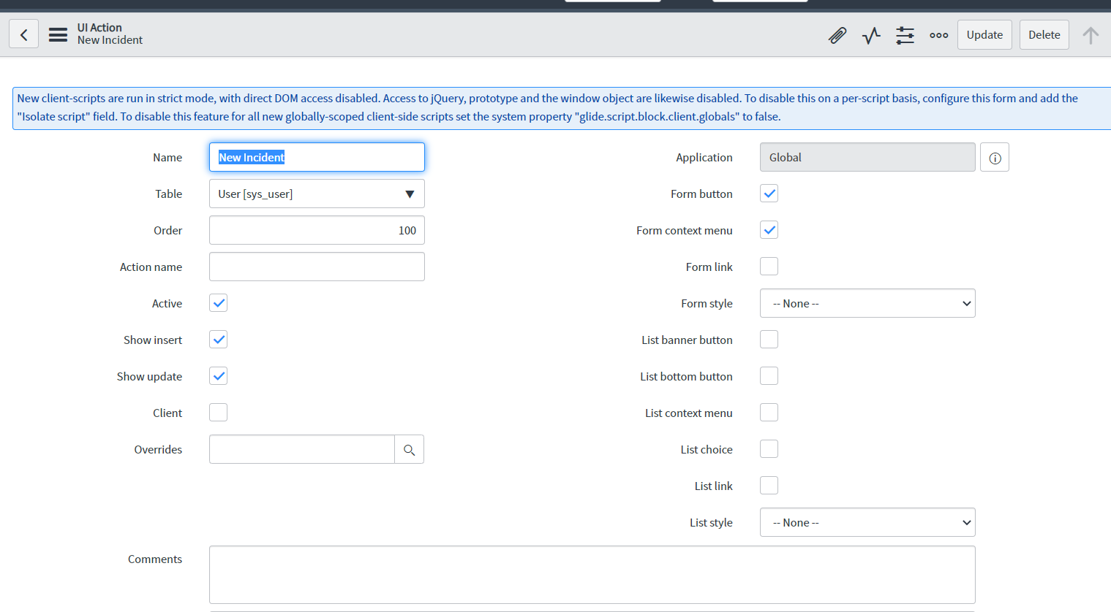

First page has entire script copied.

