Growth Experiences Configuration Guide 9:
Opportunity Marketplace
Zurich Release

This guide offers steps to set up and use Opportunity Marketplace.

This guide is 9 of 14 guides for setting up Growth Experiences applications. Make sure the Instance Set Up Guide (Guide 1) is completed prior to using this Opportunity Marketplace Configuration Guide.

Note: Guidance for integration with ATS not included. ServiceNow offers OOB integrations for Workday, Oracle and SuccessFactors HCMs. Integrations can be built for other HCMs.

Configuration Guides (links to Guides on Community)
- Instance Setup
- Skills Workspace
- Edit Employee Profile Skills Widgets
- Aspirations
- Growth Plans
- Career Hub
- Conversations Outlook Integration
- Learning
- Opportunity Marketplace (this guide)
- Mentoring
- Leader Hub
- Proactive Prompts
- Goals
- Talent Feedback

Personas:
- Admin (Opportunity admin: sn_opp_market.admin)
- Licensed Manager (Opportuntiy Owner)

Guide Overview

- Expand/collapse state
- Carousel
- No widget once all steps done
- Add/Edit user preferences
- Update preferences
- Filter opportunities
- Match Analysis
- Create an Aspiration
- Sharing an opportunity
- Other opportunities
- Create new Opportunity
- Create opportunity using SPM
- Publishing Approval

Getting to know you section

- Expand/collapse state

1. Navigate to Opportunity Marketplace Internal Jobs
- Collapse the Getting to know you widget by clicking on the arrow button up
- Refresh the page
- Notice the get started widget remains collapsed

- Carousel

- Expand the widget
- Click on the arrows to navigate through the different steps
- Click on the different actions, e.g. Set preferences to see what opens for each of them

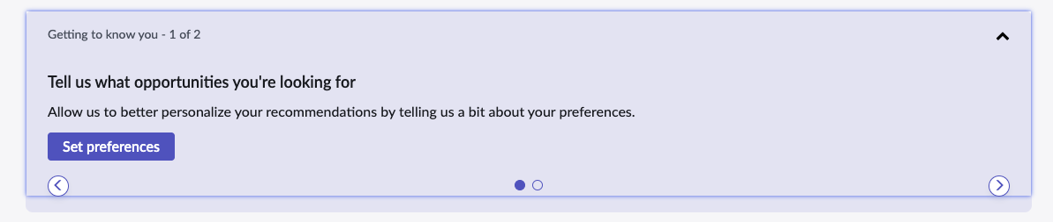

3. No widget once all steps done

- Mark all the steps as complete
- Notice how the Get Started widget does not show anymore.
- Refresh the page and it should still not show up.

- Add/Edit user preferences

Select Edit preferences option from the Internal Jobs page.

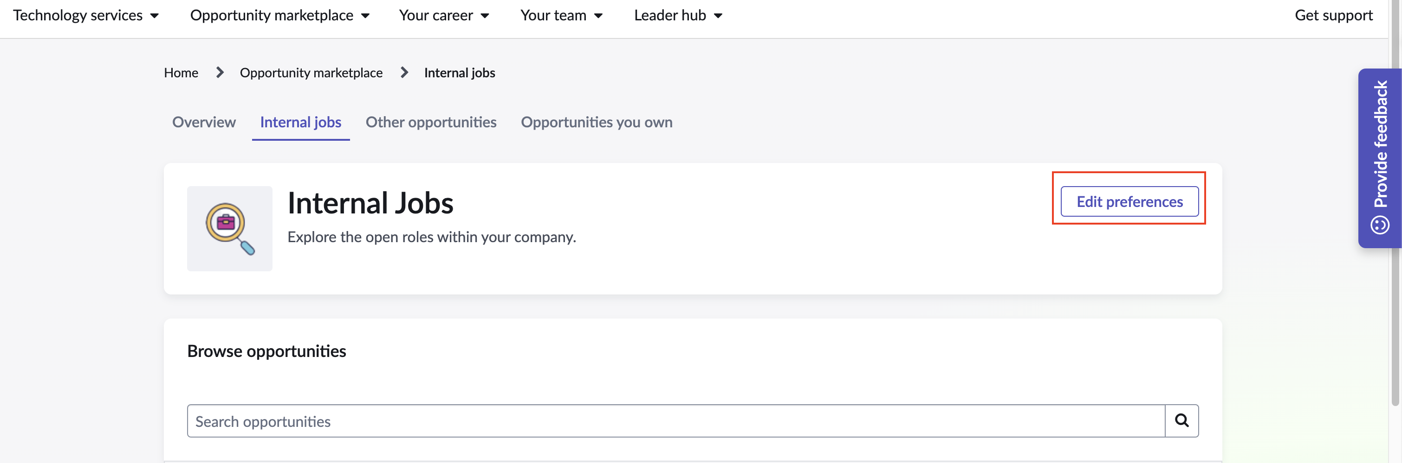

- Update preferences

From the preferences flyout you can make changes to your job search/display
preferences like working style, travel, job level, and location preferences.

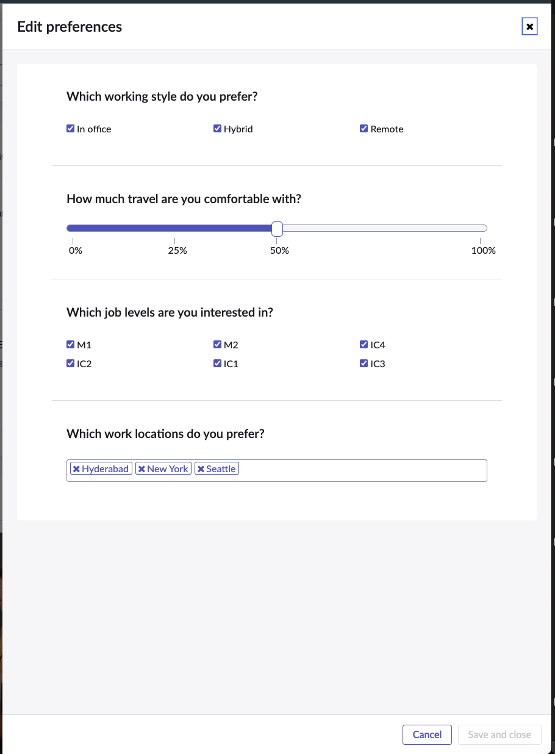

- Filter opportunities

On Internal jobs page, you can open filter and select multiple options to change
the displayed opportunities. Users can add/remove available filters which will
have an immediate effect on the job cards displayed for Based on your
widgets. Users can either individually make filter changes or all at once using the
filter flyout.

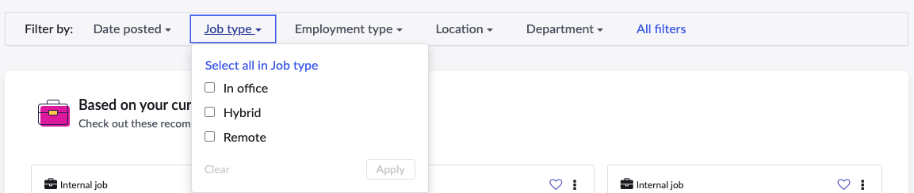
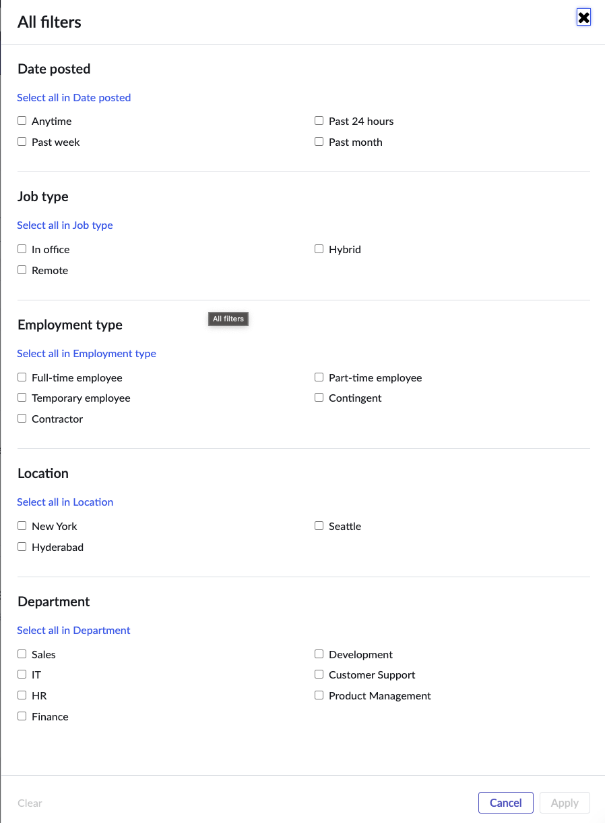

- Match Analysis

On any job card, click on the Match analysis link to see the match analysis
flyout.
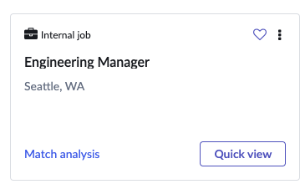

The flyout will give users a detailed analysis.

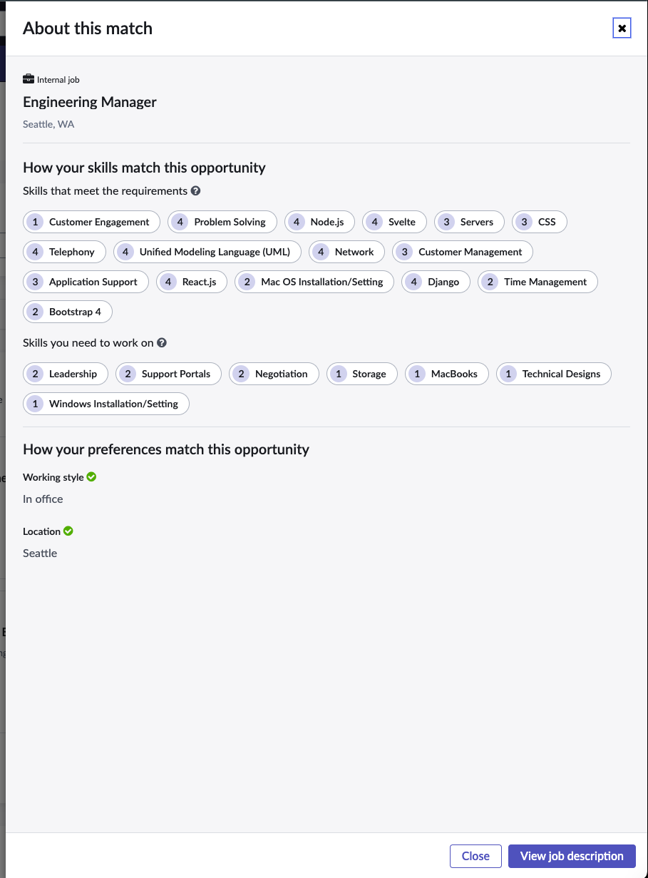

- Create an Aspiration

On any job card, select the context menu and the user should be able to
create a draft aspiration. Once the aspiration modal is open, choose a name
and description for the aspiration and click save draft.

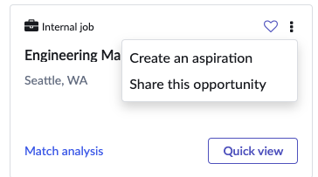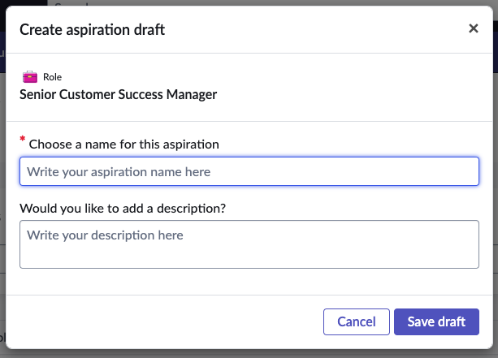

- Sharing an opportunity

On any job card, select the context menu and the user should be able to share
the selected opportunity. Search user and a personal note and click the Share
opportunity button.

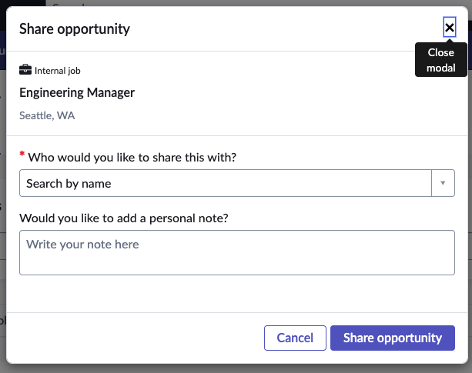

- Other Opportunities

This page lists all other opportunity types like Volunteer, Gig, Projects or any
custom opportunity type. Employee can select from AI suggested opportunities
within ‘Best fit recommendations’ widget or browse them in the following
widget. Recommendations will be calculated based on the logged in person’s
skills, current role and aspirations.
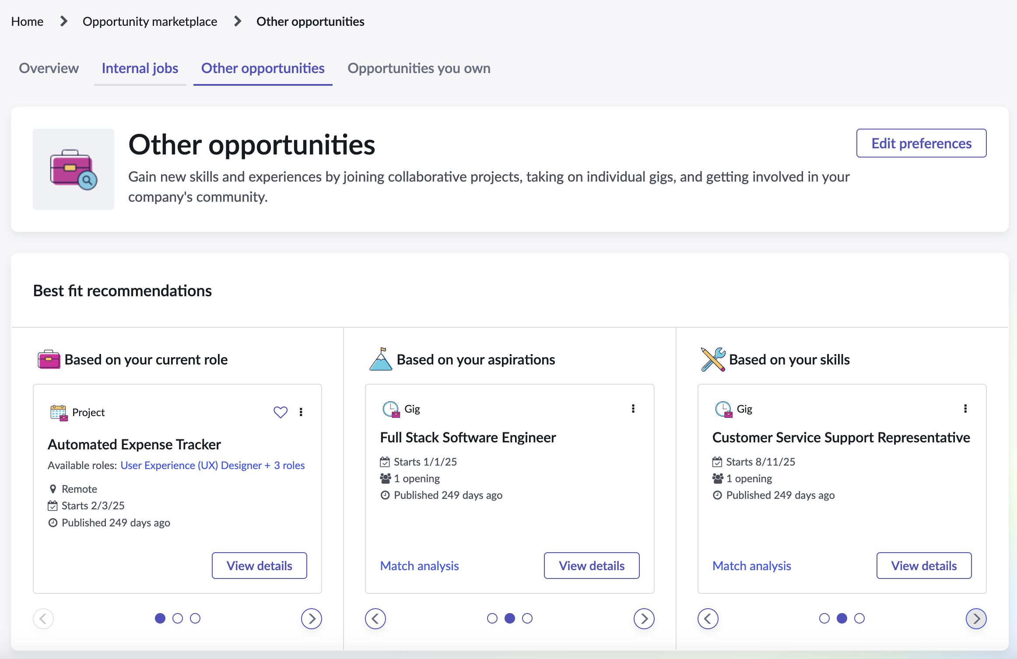

11. Create new Opportunity
Opportunity owners can create and manage projects, volunteer opportunities, and gigs under the "Opportunities you own" tab. These are added to the opportunities table. Note that internal jobs can't be created here as they come via ATS integrations. Internal jobs can be managed in the hidden tables [sn_ta_hiring_core_job_requisition] and [sn_ta_hiring_core_job_posting].

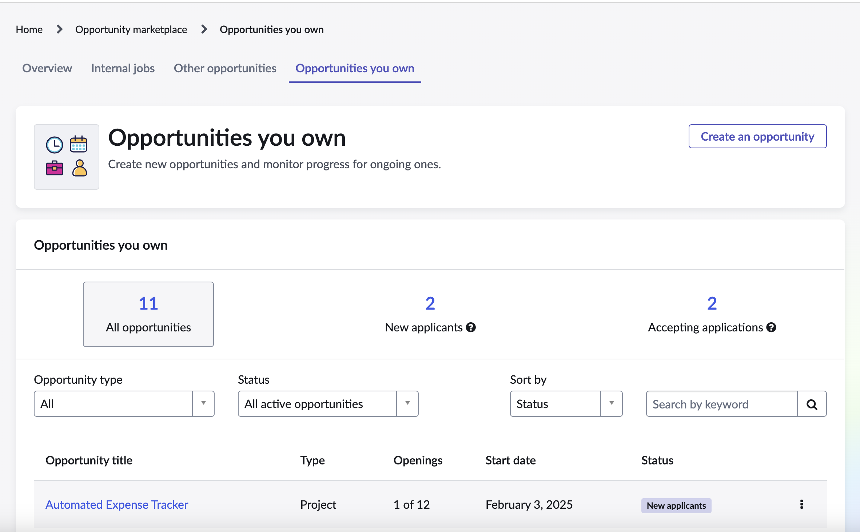

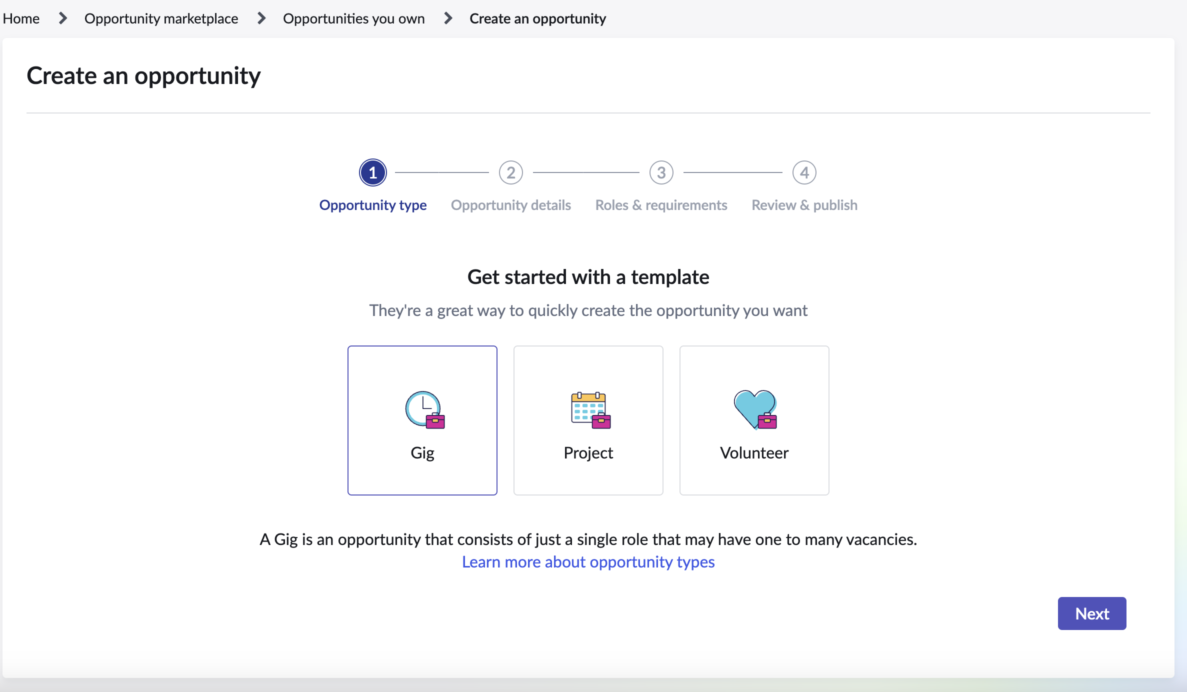

12. Create new Opportunity using SPM(Strategic Portfolio Management)

SPM users can leverage Opportunity marketplace to source for needed resources. When creating an opportunity, SPM users are able to select from their SPM projects to generate their opportunity. Employees will be able to review and apply for these opportunities that are relating to SPM prjects.

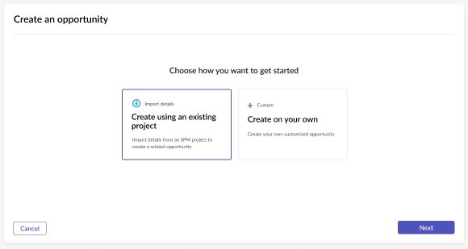
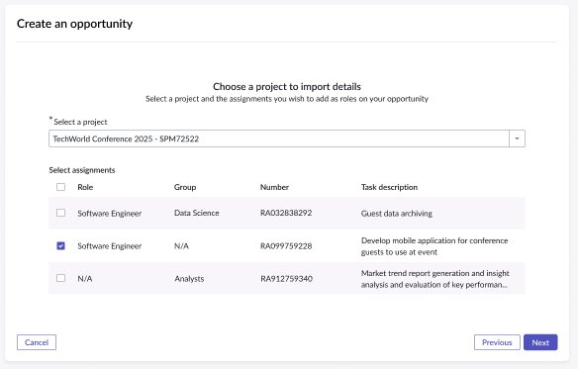

To use this customer must have implemented both SPM(Strategic Portfolio Management and HRSD Professional or Enterprise).
Note- There is no feed from Opp. Marketplace to SPM as such, selected candidates will have to be manually associated to projects in SPM. As all activity is occurring in Opportunity Marketplace app.

- Opportunity Publishing Approval
Opportunity ownercan create a draft opportunity posting and request approval from creation team. Opp owner will receive confirmation that approval request is submitted and can monitor the approval status via ‘Opportunities you own’ section. This can be configured according to the requirement if approval is needed or not.

