Growth Experiences Configuration Guide 7:
Conversations Outlook Integration
Zurich Release

This guide offers steps to set up the Conversations Outlook Integration.

This guide is 7 of 14 guides for setting up Growth Experiences applications. Make sure the Instance Set Up Guide (Guide 1) is completed prior to using this Conversations Outlook Integration Guide.

Configuration Guides (links to Guides on Community)
- Instance Setup
- Skills Workspace
- Edit Employee Profile Skills Widgets
- Aspirations
- Growth Plans
- Career Hub
- Conversations Outlook Integration (this guide)
- Learning
- Opportunity Marketplace
- Mentoring
- Leader Hub
- Proactive Prompts
- Goals
- Talent Feedback

Guide Overview
- Setting up Exchange spoke
  - Application Registry
  - Create Credentials
  - Credentials Aliases
  - Webhook registry
- Using the Career Conversations app
- Creating and Modifying Conversations Using the Growth plans app
- Using the Mentor (Career Connections) app

- Setting up Exchange Spoke
1a. Application Registry
Persona: admin
- Log into your instance:
- Set scope to “Microsoft Exchange Online Spoke”
- Navigate to Application Registry
- Click Microsoft Exchange Online

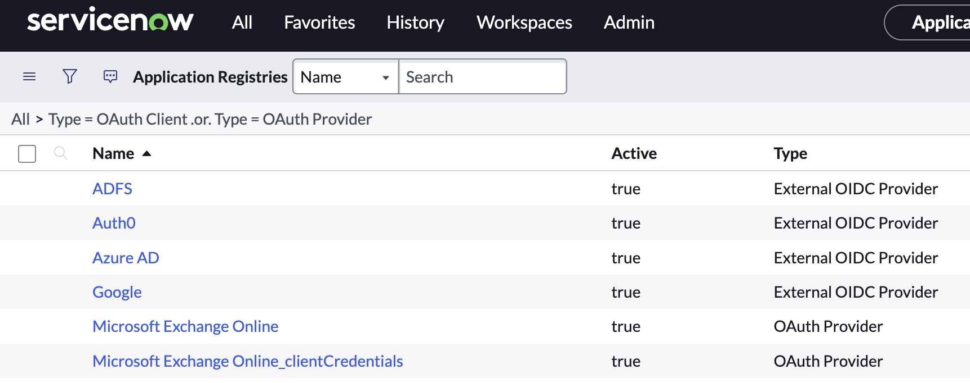

- Complete the following fields:
- Client ID: 88ad73b0-35c9-4507-86e2-33d67c4839b1
- Client Secret: f80f5d02-9c3d-4871-8ab7-004cdd1beffd
- Redirect URL: https://<YOUR_INSTANCE>.service- now.com/oauth_redirect.do
- Click Update
- Repeat for Microsoft Exchange Online_clientCredentials

1b. Create credentials

Persona: admin

- Navigate to Connections & Credentials > Credentials
- Click New
- Oauth 2.0 credential
- Complete the following fields:
- Name: EGD exchange spoke
- Oauth Entity Profile: Microsoft Exchange Online default_profile
- Right click and select save
- Click Get Oauth Token in related links

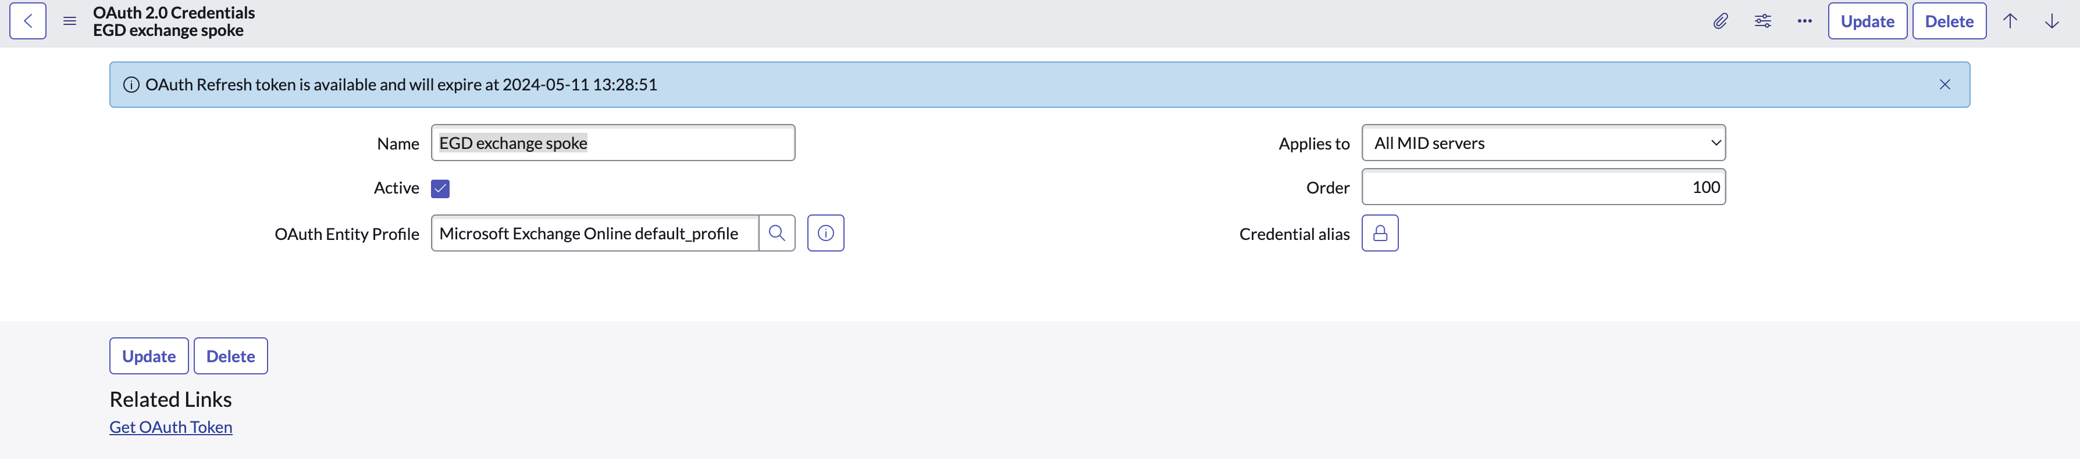

- Repeat the steps to create a new credential with the following details:
- Name: EGD exchange spoke_clientCredentials
- Oauth Entity Profile: Microsoft Exchange Online_clientCredentials default_profile

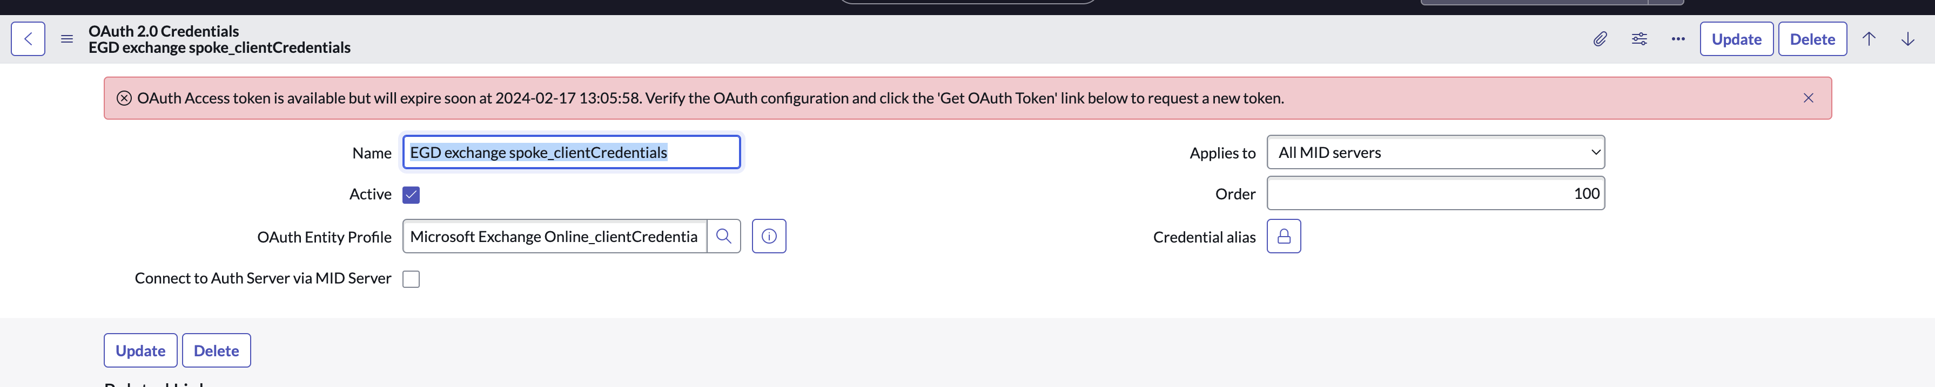

1c. Credential Aliases

Persona: admin

- Navigate to Connections & Credentials > Connections & Credentials Aliases
- Click Microsoft_Exchange_Online
- Go to the Connections related list, click new
- Fill in the following fields:
- Name: EGD exchange spoke
- Credential: EGD Exchnage Spoke
- Connection URL: https://graph.microsoft.com
- Click Submit
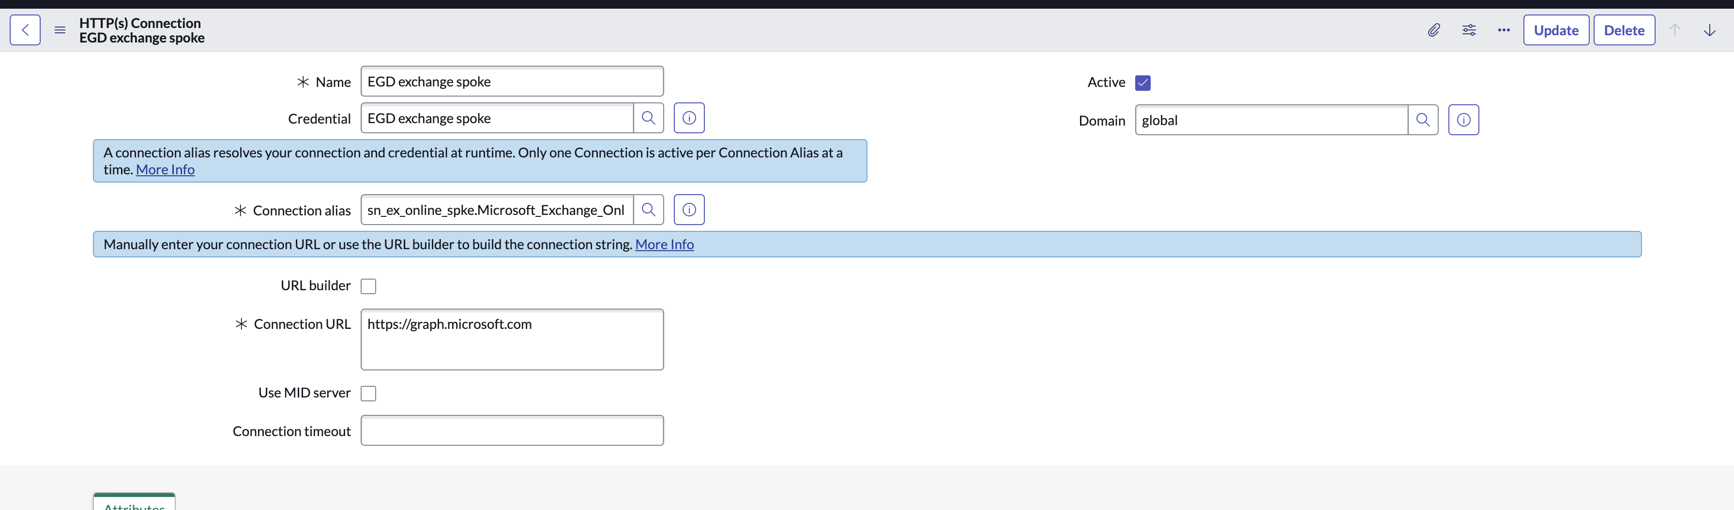

- Navigate to Connections & Credentials > Connections & Credentials Aliases
- Click Microsoft_Exchange_Online_clientCredentials
- Repeat steps 3 to 5 but fill out the fields as shown below

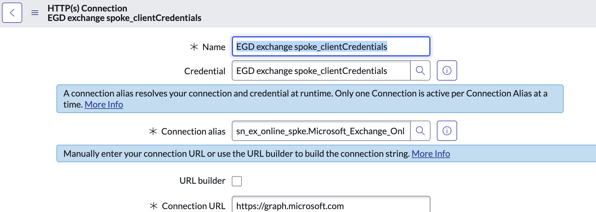

1d. Webhook Registry:

Persona: admin

- Navigate to Microsoft Exchange Online Spoke > Webhook Registry
- Click New
- Fill in the following fields
  - Name: HRSD webhook
- Right click & save
- Click Callback URL button
- Save the URL and update the sn_egd_act.ex_online_notification_url sys property identified in the Requirements Summary

- Using the Career Conversations app

Persona: Licensed Manager

- Navigate to the Employee Center
- Navigate to Your team, Conversations.

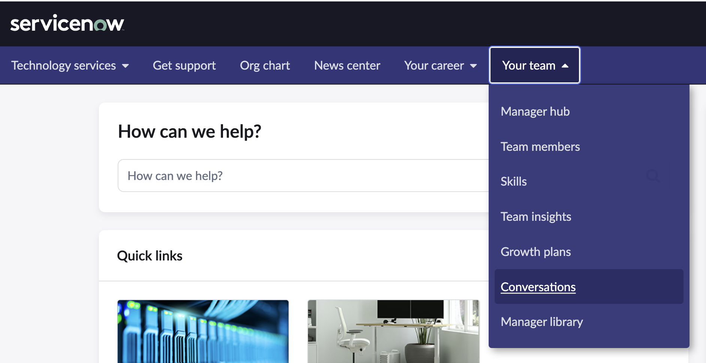

- The manager landing page opens in the Career Conversations app.
- Click the Schedule conversation button to bring up the Outlook Scheduling flyout.

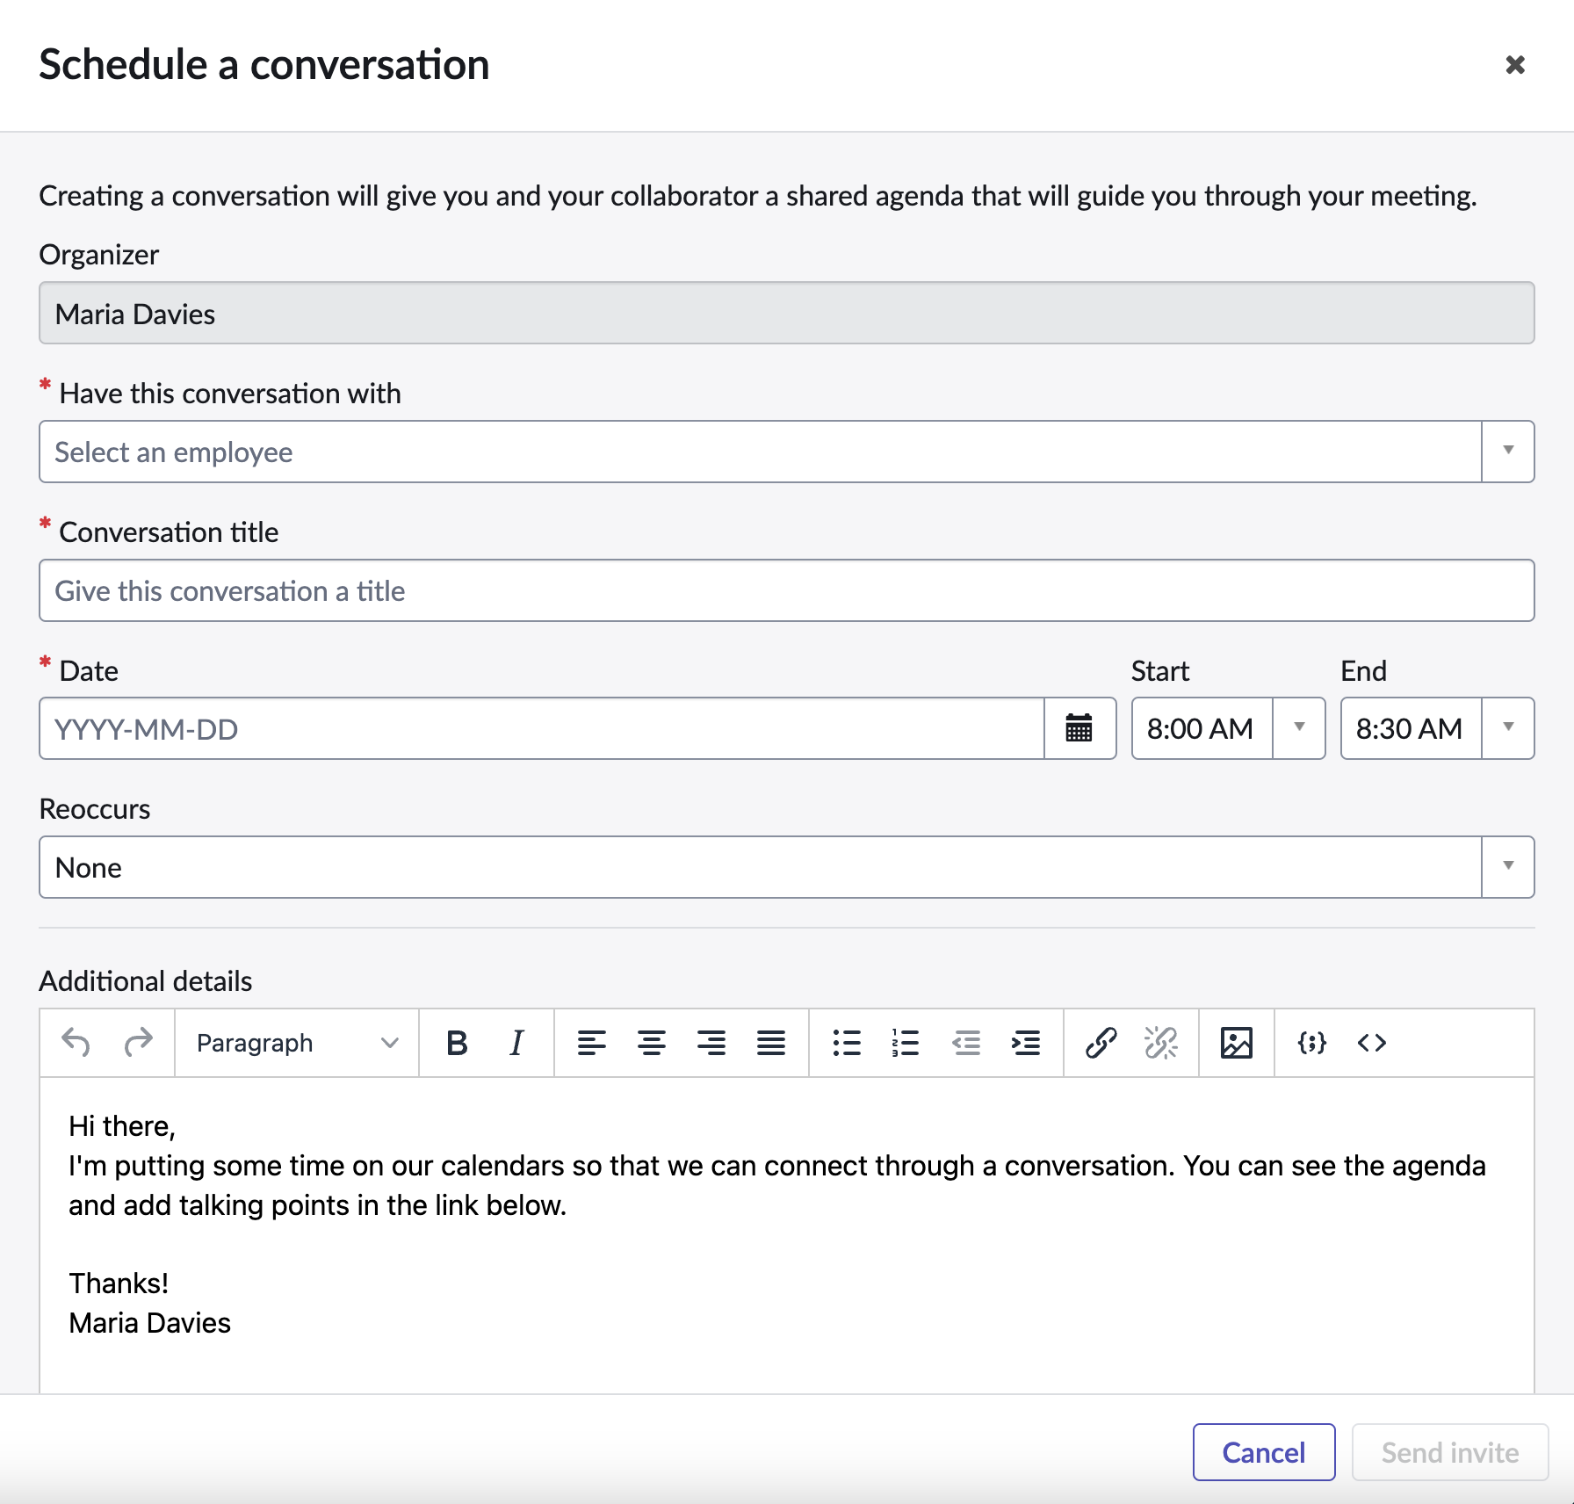

- Choose an employee in the Have this conversation with field.
- The title is defaulted, change if you wish.
- Choose a cadence for Reoccurs, like One time.
- Click the date field and the calendar will open to that day.

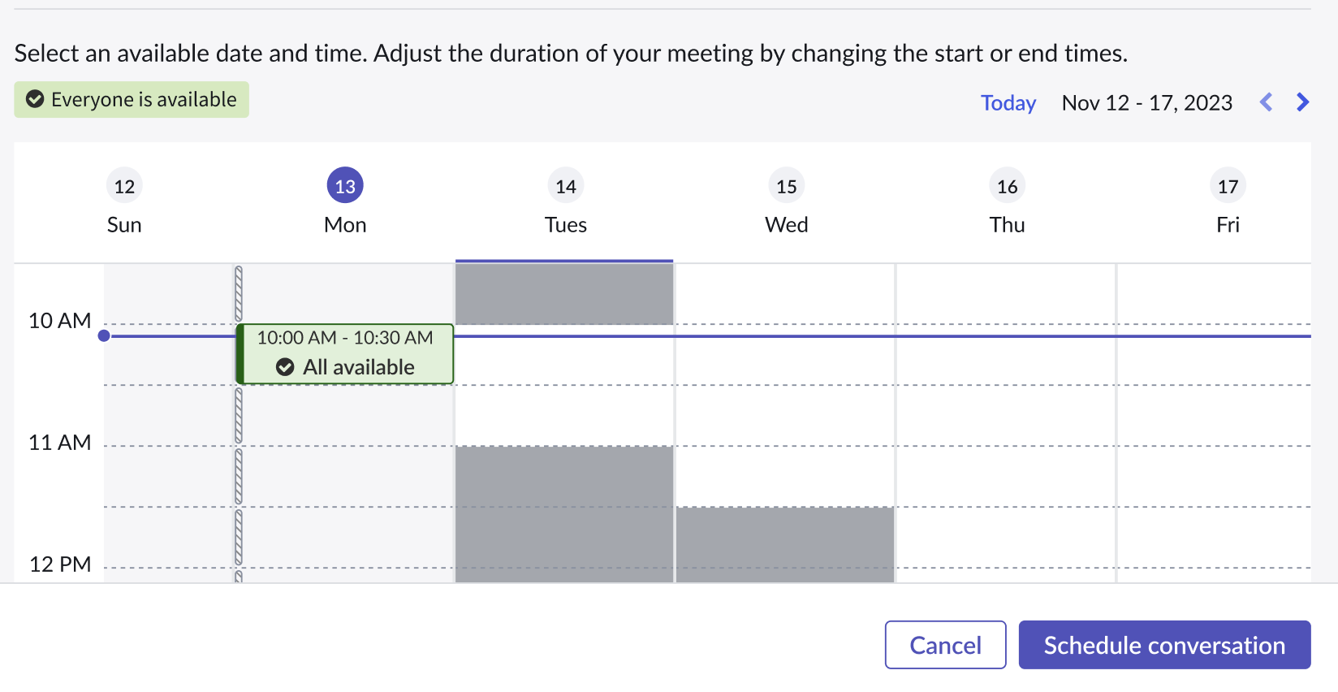

- Grey boxes show times when the employee, manager, or both are busy.
- Choose a time with the calendar or time/date fields.
- Update or change the text in Additional Details if desired.
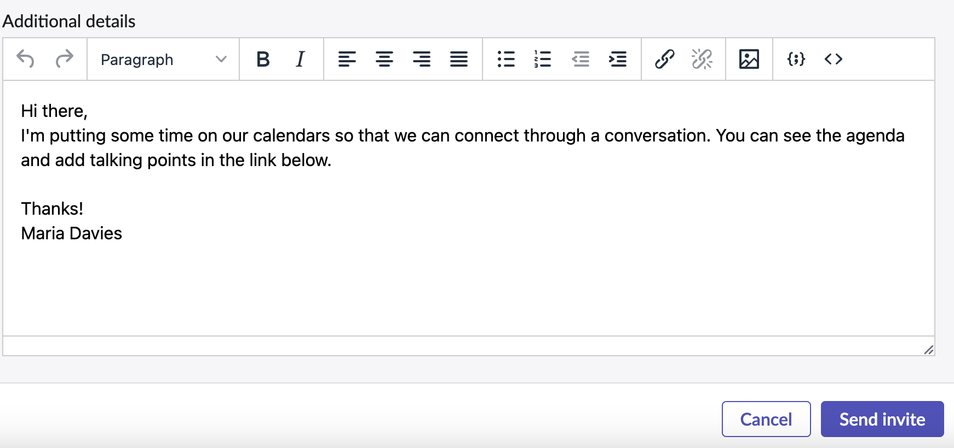
- Click Send Invite to schedule and create the Conversation.
- The flyout will close and you can see the conversation created in the Your team’s conversations widget on the manager landing page.
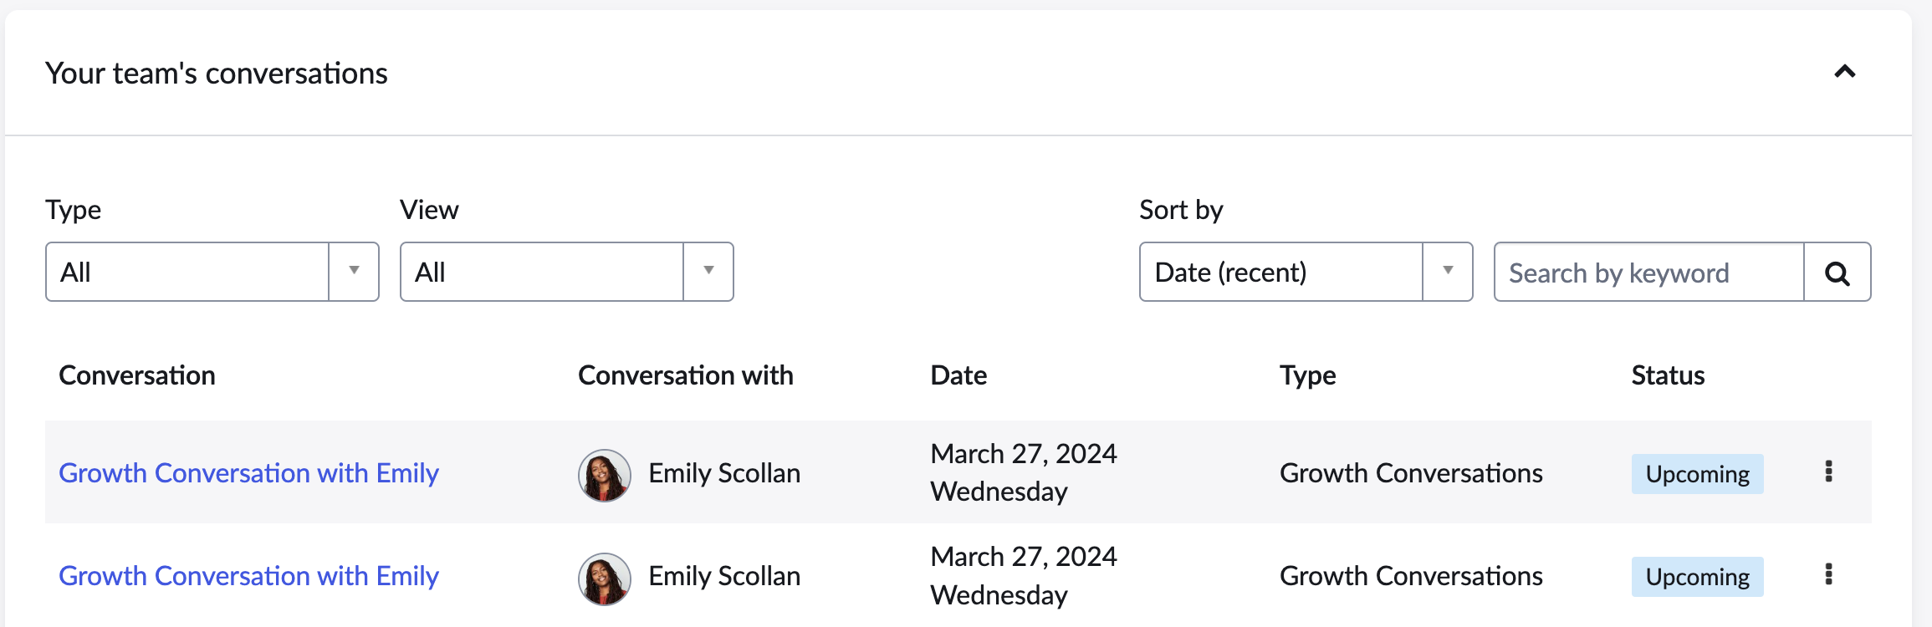

- The conversation is now created.
- To modify or change the schedule of the conversation, click any of the conversations on this widget to open the Agenda page.
- The Agenda page shows all conversation details and the conversation can be modified or rescheduled by clicking the Edit details button. Click it.

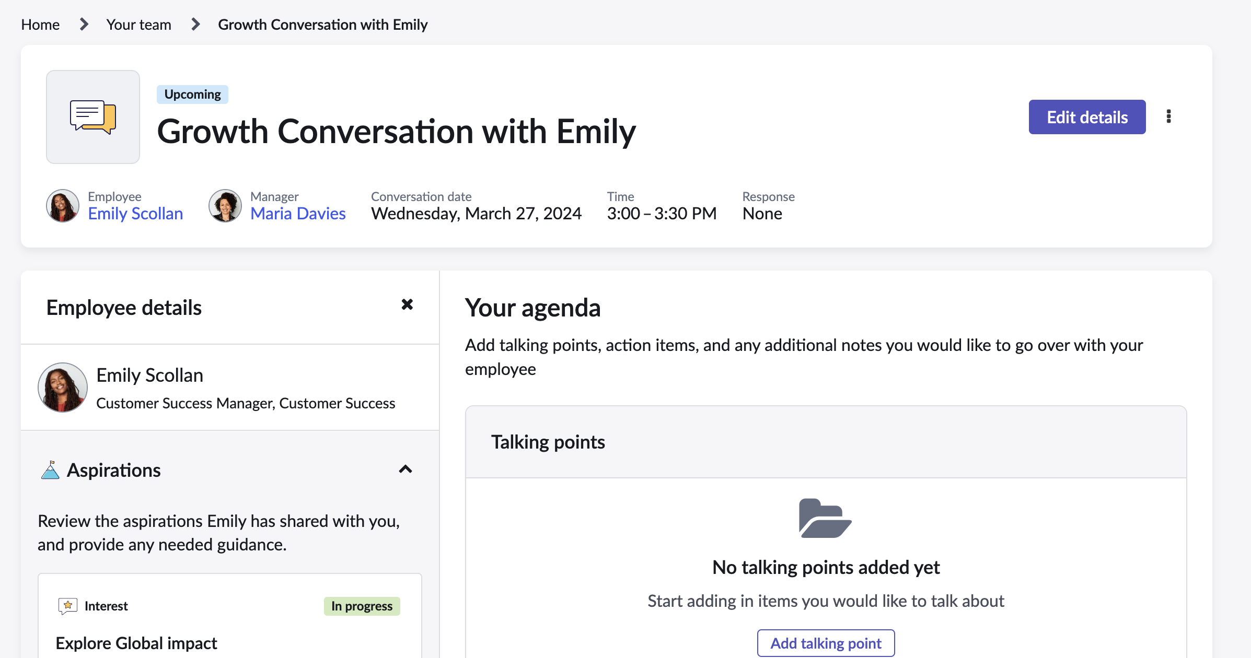

- The Conversation Scheduling flyout will open with all the meeting details. You can change any aspect of it including the date/time. Choose a different date/time by clicking on a new slot in the calendar.

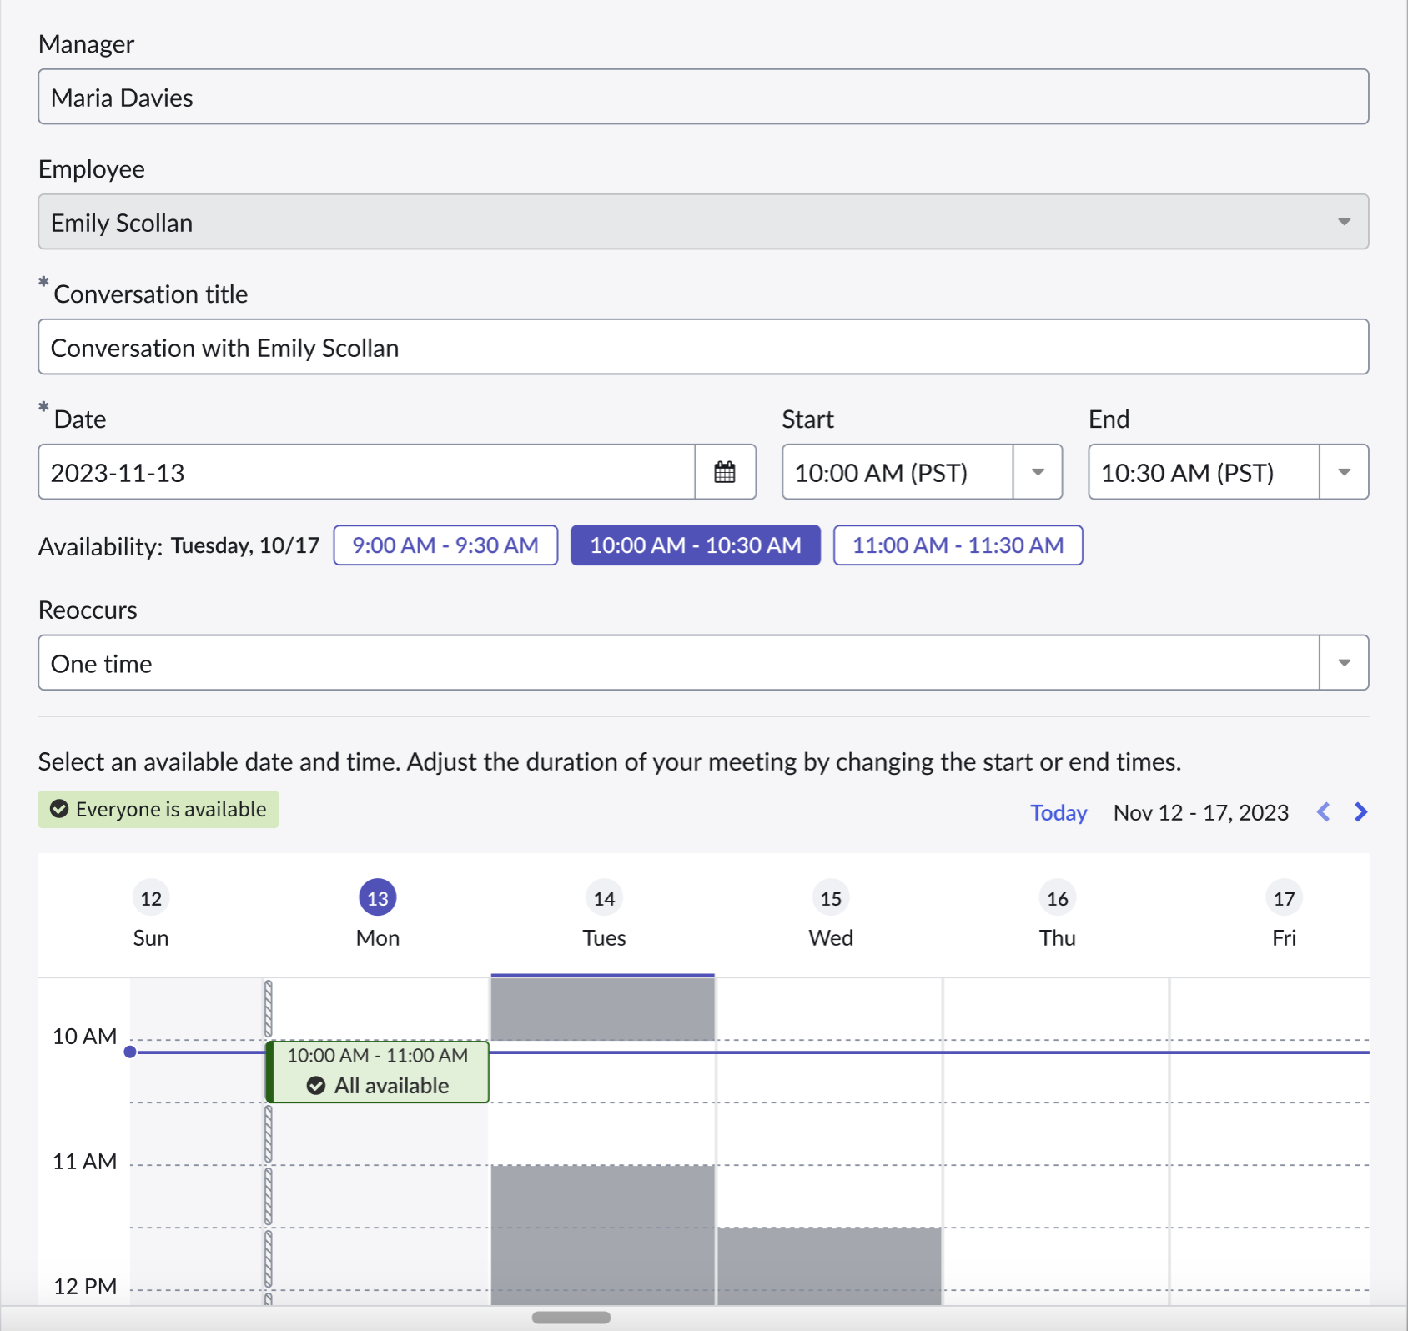
- Click the Send Update button to save the update and send the updated invite to the employee.
- This covers creating and updating a Conversation using the Career Conversations application. Note that any Conversation can be modified in this app regardless of whether it was created in the Mentor or Growth Plans applications.

- Creating and Modifying Conversations Using the Growth plans app

Persona: Licensed Employee
- Navigate to the Employee Center
- Click on Your Career, Growth Plans

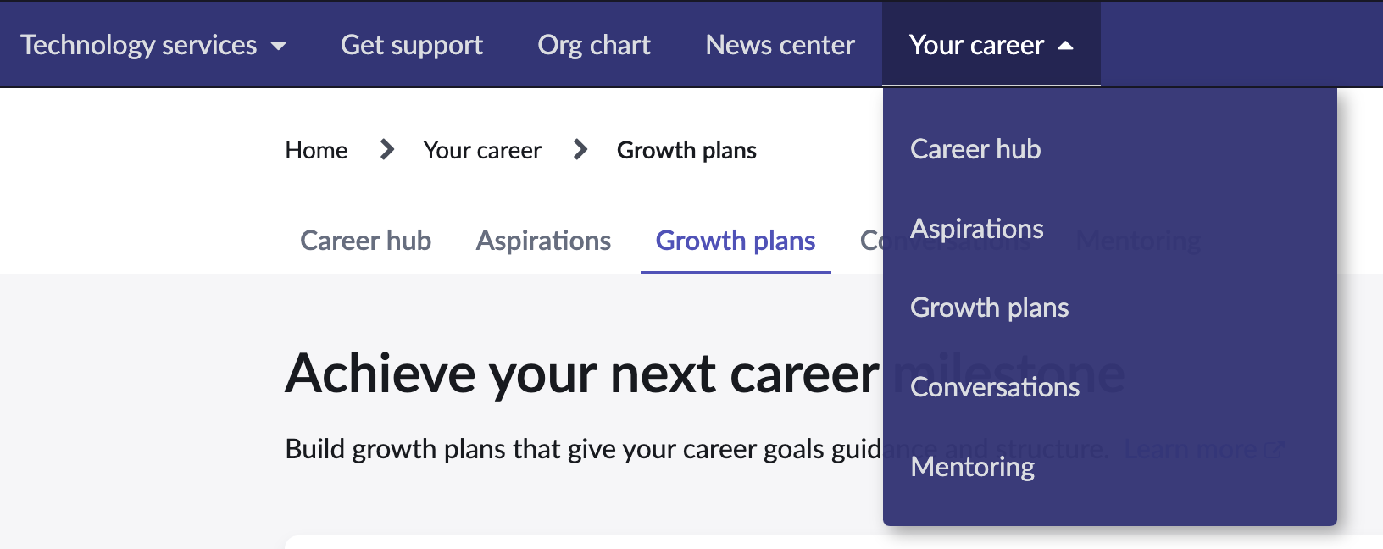

- Click the Create a growth plan button.

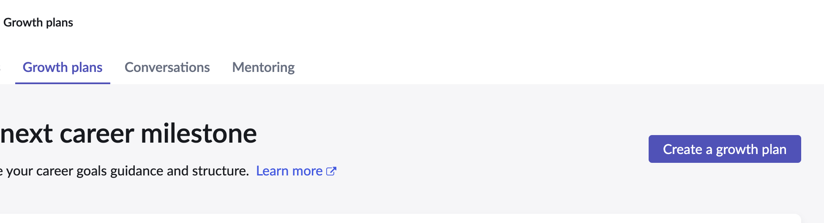
- Follow the growth plan creation flow. Ensure that it has as Check-in activity as part of the plan.
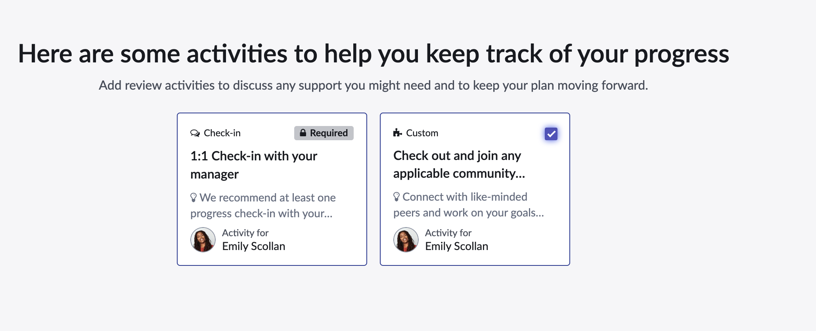
- Finish the flow and create the growth plan.
- Under the Plan activities widget, click the Check-in activity.
- This opens the conversation flyout.

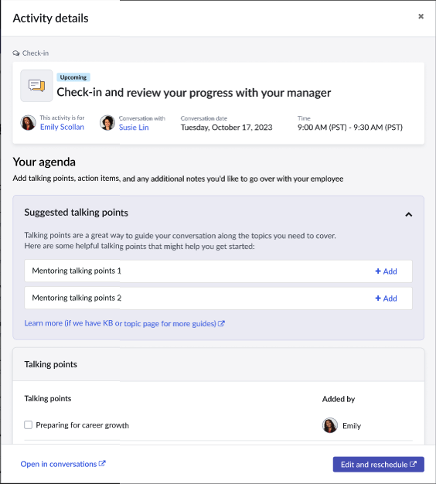
- Click Edit and reschedule, this will open the Agenda page in the Career Conversations app and open the Scheduling flyout (step 17 in the previous section.)
- The reschedule flow is the same as steps 17-20 in the previous section.

- Using the Mentoring app

Persona: Licensed Employee
- Navigate to the Employee Center
- Click on Your Career à Mentors, this will open the mentor landing page.
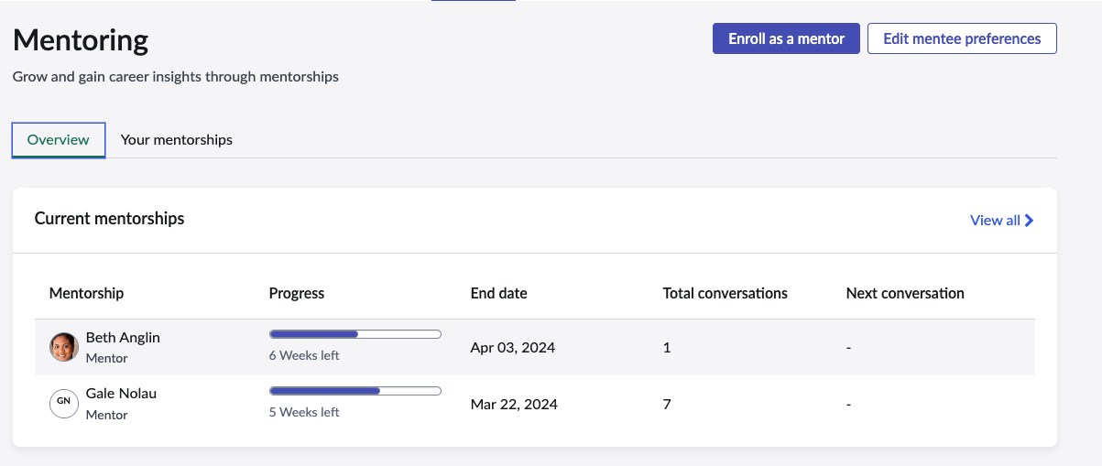
- Click the Your mentorships tab to see the show the employees active mentorships. Click the kebab menu and choose Create conversation.
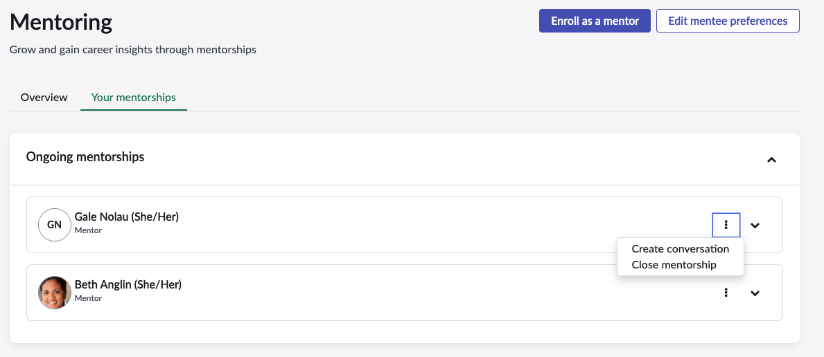
- This will open the same flyout that was shown in step 7 previously. Follow steps to navigate to the Conversations app and schedule the conversation.

