Growth Experiences Configuration Guide 4:
Aspirations
Zurich Release

This guide offers steps to set up and use Aspirations.

This guide is 4 of 14 guides for setting up Growth Experiences applications. Make sure the Instance Set Up Guide (Guide 1) is completed prior to using this Aspirations Configuration Guide.

Configuration Guides (links to Guides on Community)
- Instance Setup
- Skills Workspace
- Edit Employee Profile Skills Widgets
- Aspirations (this guide)
- Growth Plans
- Career Hub
- Conversations Outlook Integration
- Learning
- Opportunity Marketplace
- Mentoring
- Leader Hub
- Proactive Prompts
- Goals
- Talent Feedback

Guide Overview
- Personas
- Roles
- Review and Create Interest Records
- Role Based Aspiration Creation
- Skill Based Aspiration Creation
- Interest Based Aspiration Creation
- Aspiration Modification
- Manager Specific Flow: Employee Profile
- Manager Specific Flow: Conversations App

1. Personas
a. Employee​
- Create aspirations and share them with their managers or peers​
- Create growth plans based on their aspirations​
- Create check-in meetings in the Conversation application​
- Track their aspirations and associated growth plans in the Growth Plan application​
b. Manager​
- Track their employees’ aspirations allowing them to provide opportunities to reach them​
c. Growth Admin​ (previously Talent Admin)
- Creates and maintains “Interest” records that aspirations can be linked with​
- Maintains aspiration “types” if a customer wants to modify or change them
- Roles
sn_egd_core.admin​
- CRUD access to aspirations, aspirations types, and interests​
Please note: this access is limited to platform view, admin would need license to have portal access.​
sn_egd_core.content_manager​
- Can Read aspiration types​
- CRUD access to interests​
Employees
- CRUD access for their own aspirations, growth contexts and skills related to their aspiration​
- Read access to aspirations shared with them

- Review and Create Interest Records

Role required: sn_egd_core.admin
- Navigate to Talent Development Core > Aspirations > Interests.
- Click New.
- Complete the following Fields:
- Name: (Example) Community Outreach
- Order: 50
- Topic: Donating and Volunteering
- Title: Helping others in our community
- URL: https://www.sandiegocounty.gov/content/sdc/sdhcd/about-us/community-outreach/
- Description: “Our goal is to make homes and communities safe, healthy and thriving.
A thriving community is one that promotes the diverse strengths and cultures in the region.”
- Click Submit
- You can now see your new interest in the list view, and it will be available in the app for use.

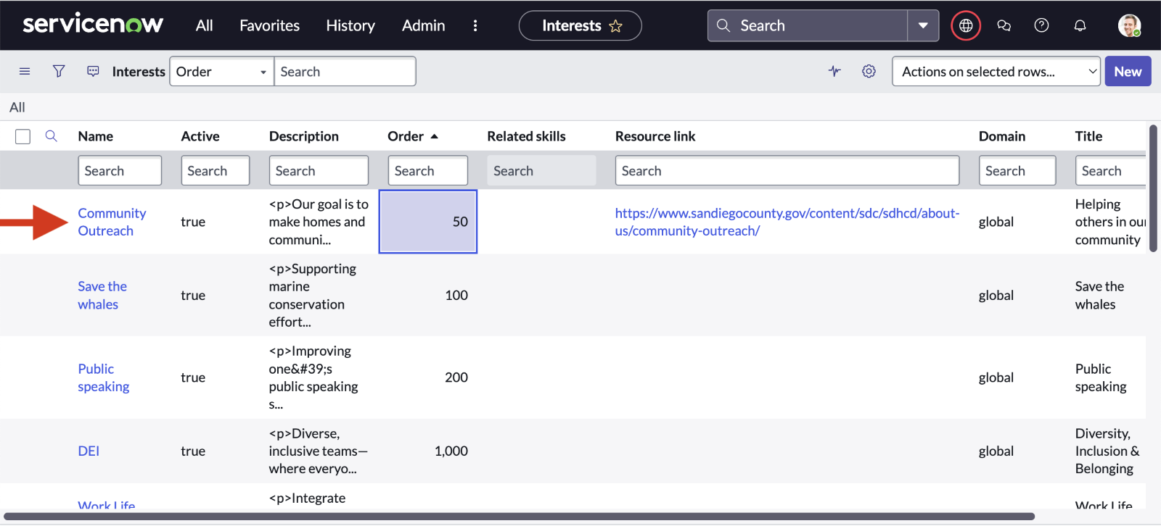
- Role Based Aspiration Creation
Note: This guide references demo data (Emily Scolan and Maria Davies).

- Navigate to the Employee Center module to open up the Service Portal.
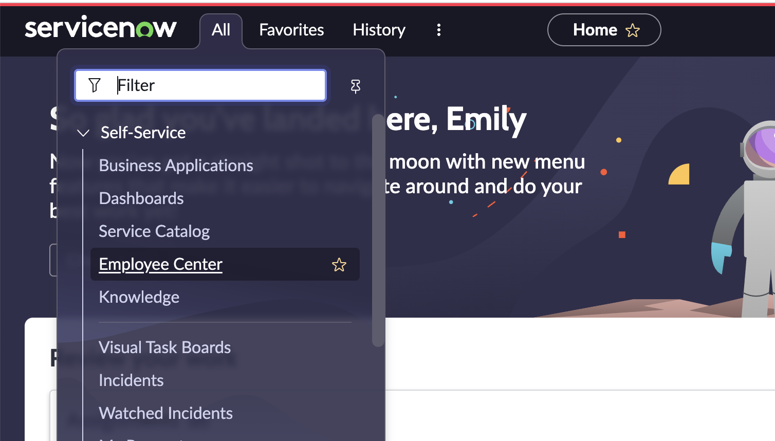

- Navigate to the Aspirations choice in the Your career menu.

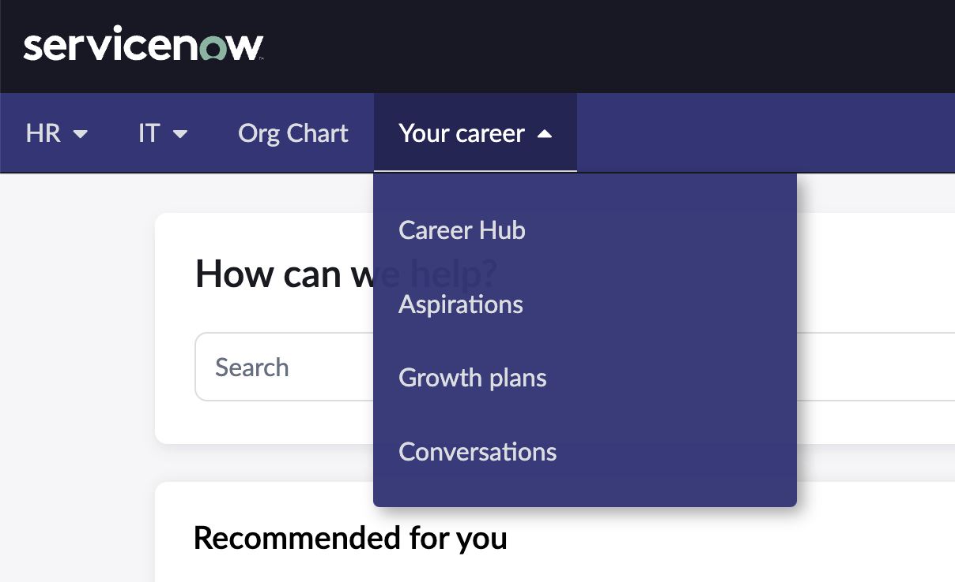

- The main Aspiration page opens up showing.

Click the Aspirations tab to create a new aspiration.



The What’s next widget shows suggestions from the Skills Engine for Role and Skill based aspirations.
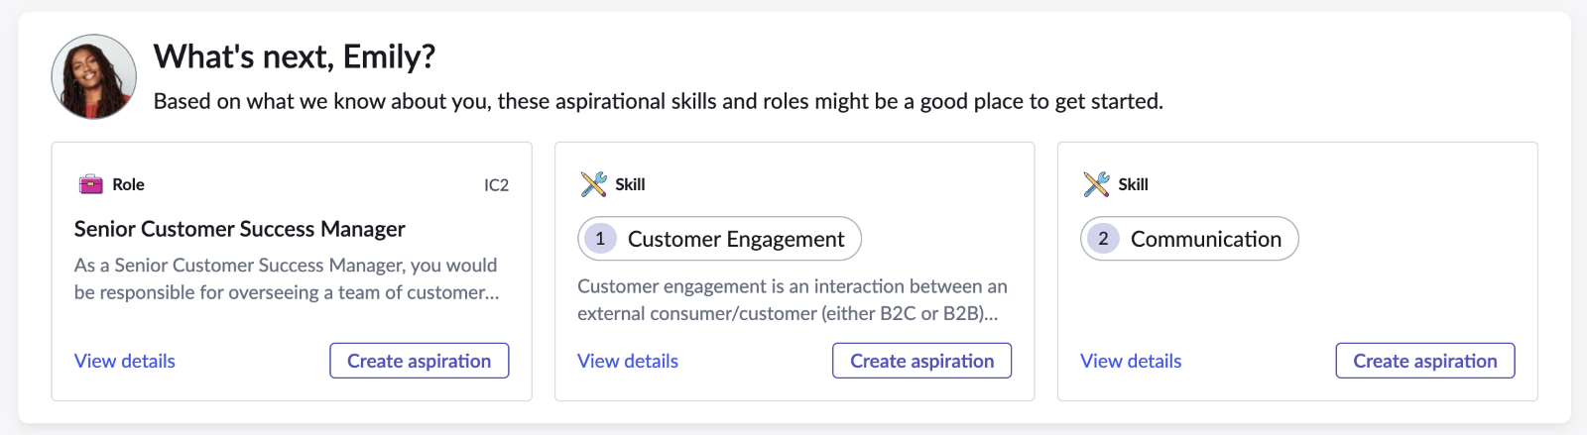

Your aspirations widget shows all aspirations the employee has created so far.

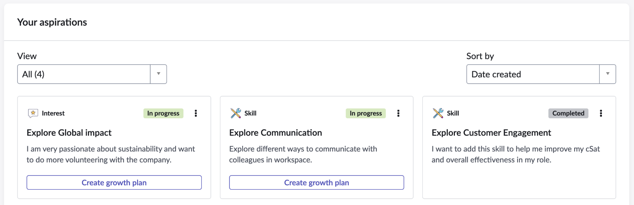

Click the Create a new aspiration button in the first widget to start the aspiration creation flow.

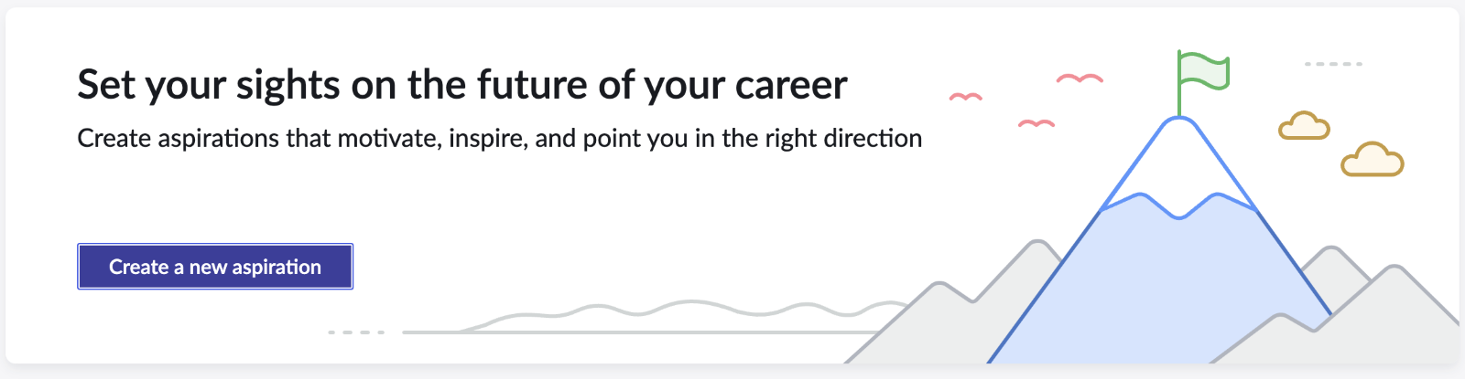

Choose Moving toward a new role and click next. This starts the flow for creating a role based aspiration.

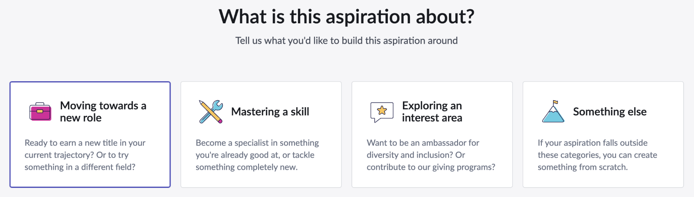

Suggested roles are shown in cards and the search bar allows looking for other roles.

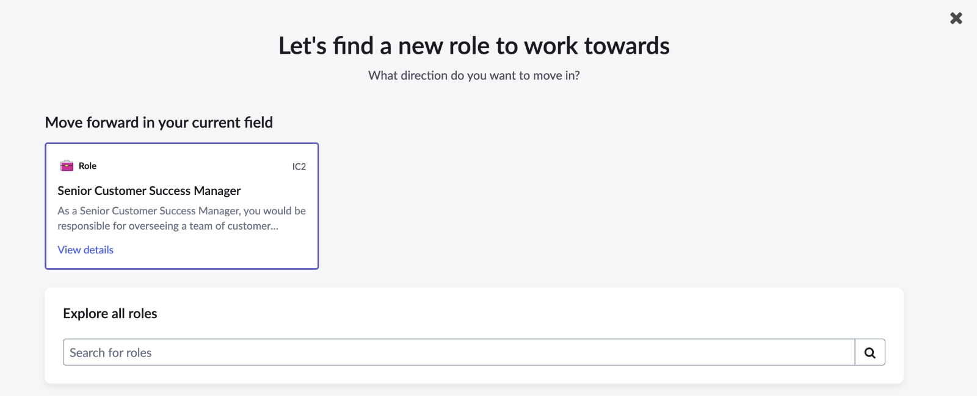

Click View details in the card to query and see more details on this role.

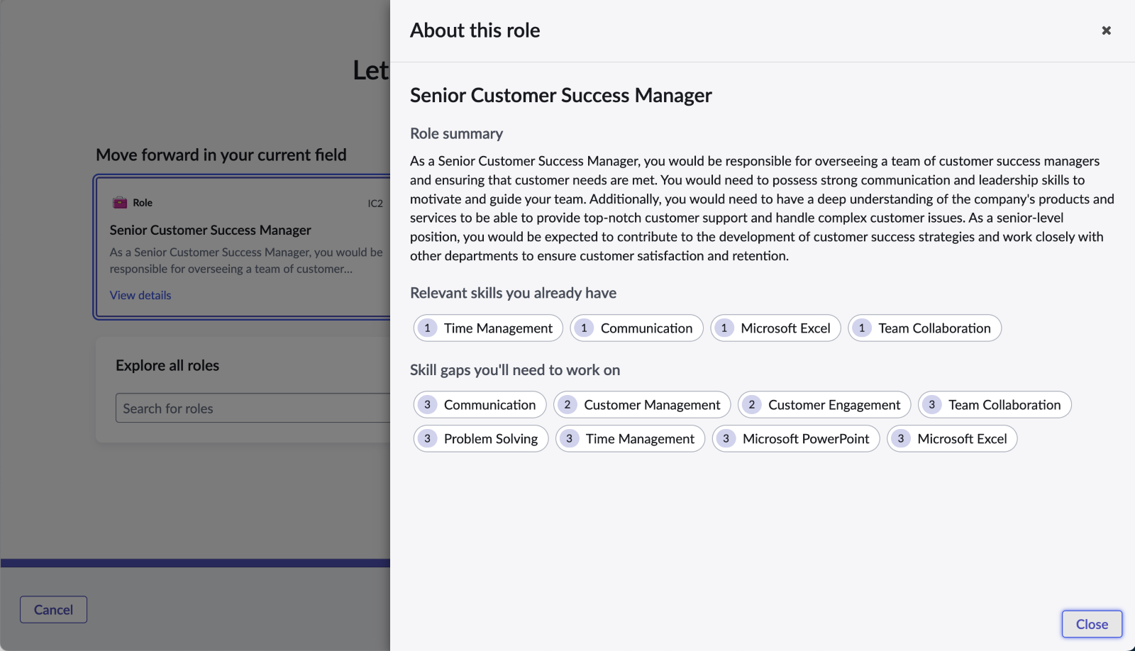

Click close, and then search on the word Manager in the Explore all roles search bar. This will return a set of other roles in the Skills Intelligence app that match that keyword.

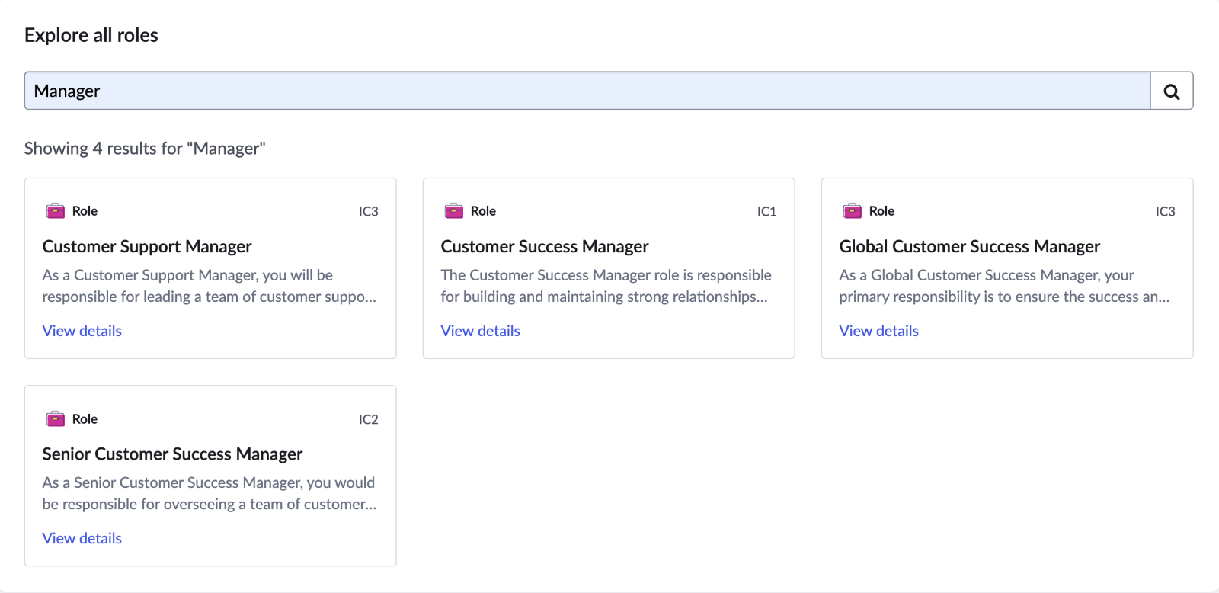
Choose a card and click next to move forward. This opens the Details screen fill out the fileds as follows:
- Aspiration Name: Become a Senior Customer Success Manager (defaulted)
- Description: (Google Customer success manager job description and cut/paste something)
- When do you hope to achieve this aspiration: Within the next six months

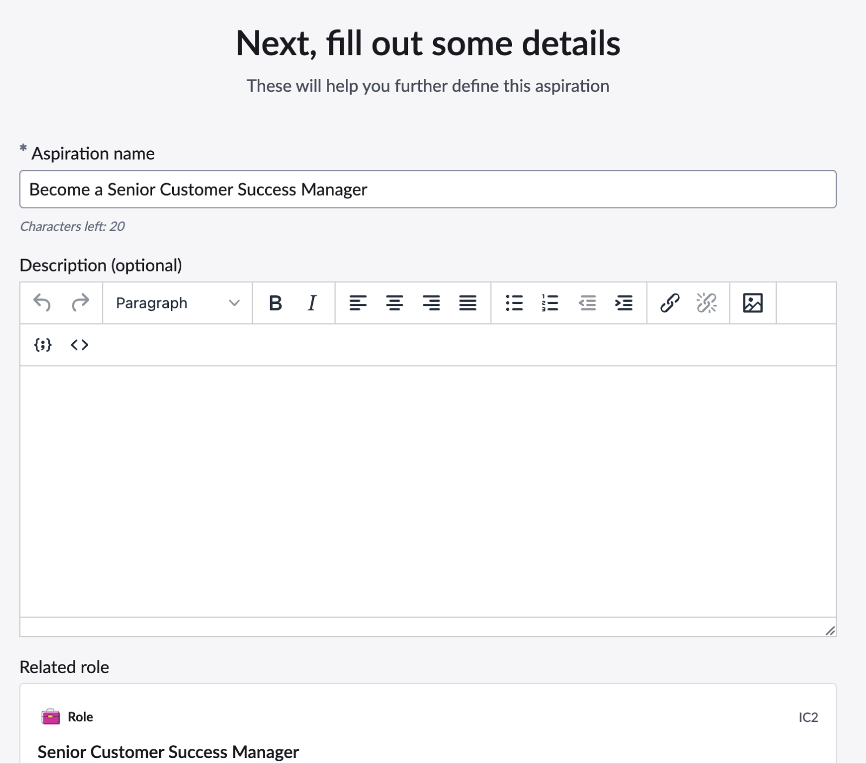

Click Next.

This opens the Last step page in the flow. Set the following options:
- Who can see this aspiration: You and your manager
- Do you want to send them a notification: Yes
- Message: This is defaulted, you can change it if you wish
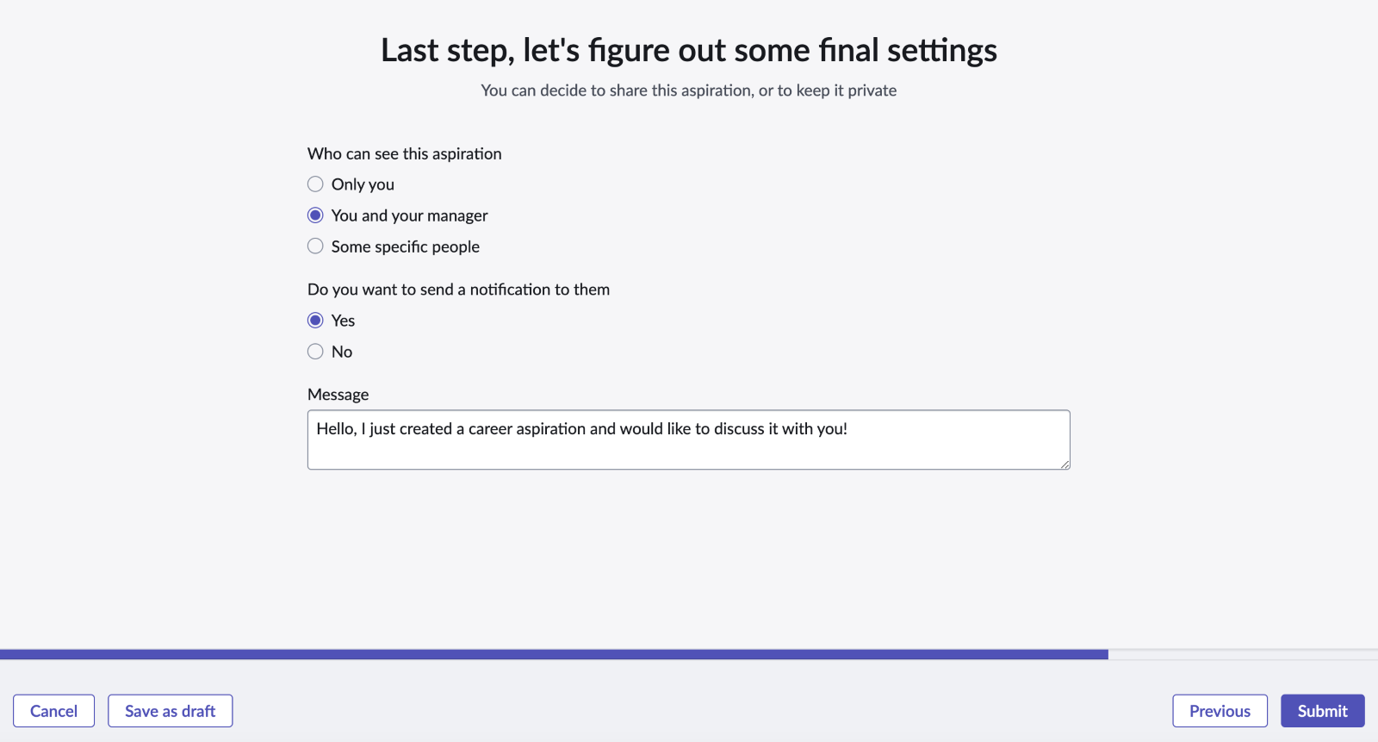

Click Submit. The aspiration flow is complete and you see the Your aspiration has been set screen. You can create another aspiration, view your current aspirations back in the Aspirations main page, and you have the option to create a growth plan for this aspiration.

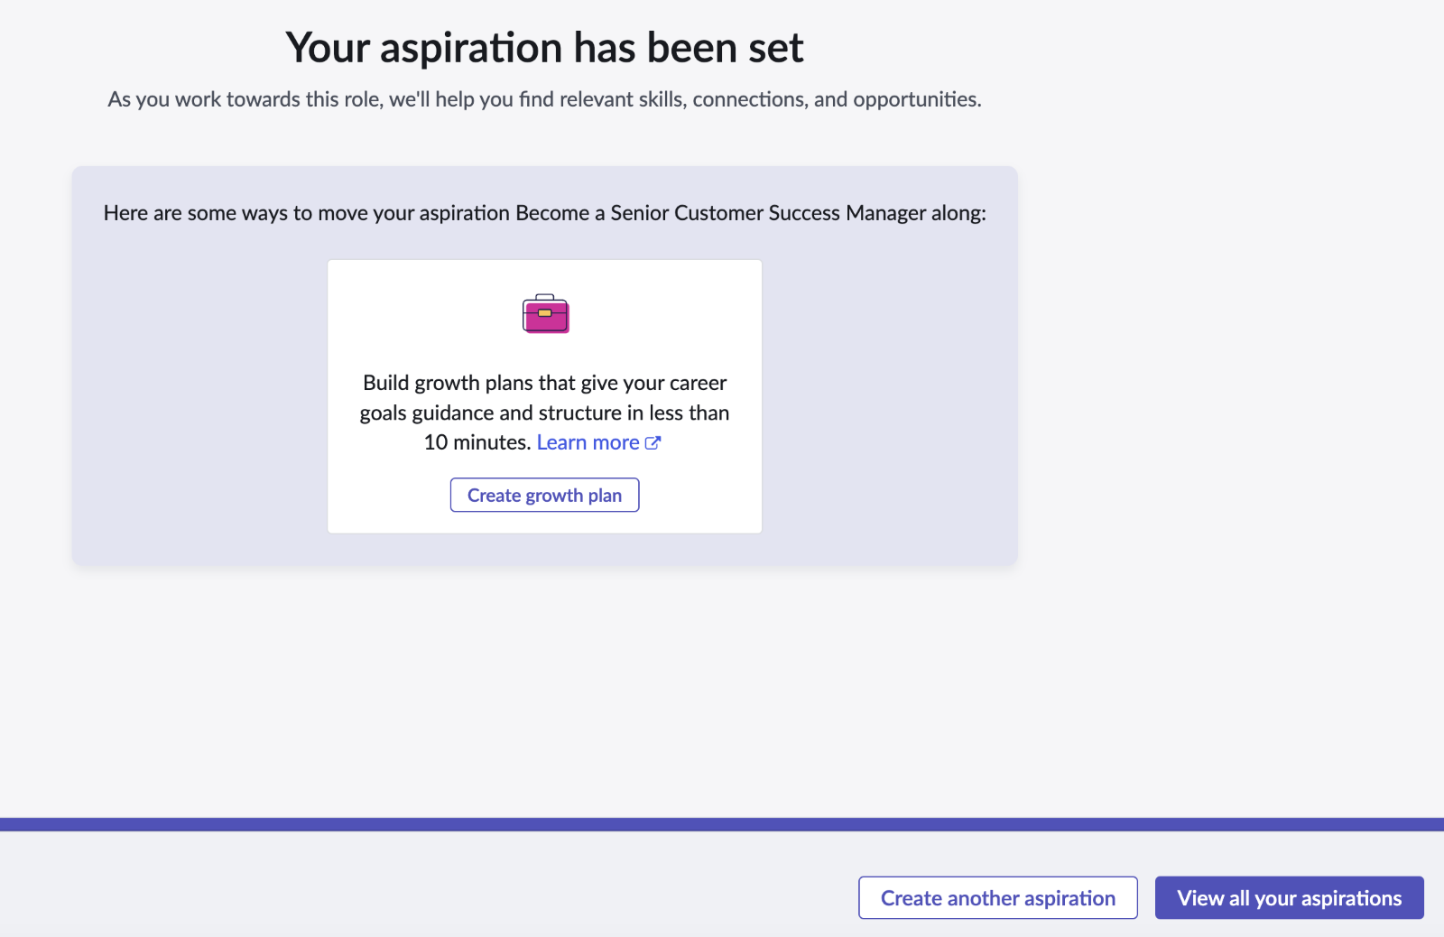

Click Create growth plan, then Get started.

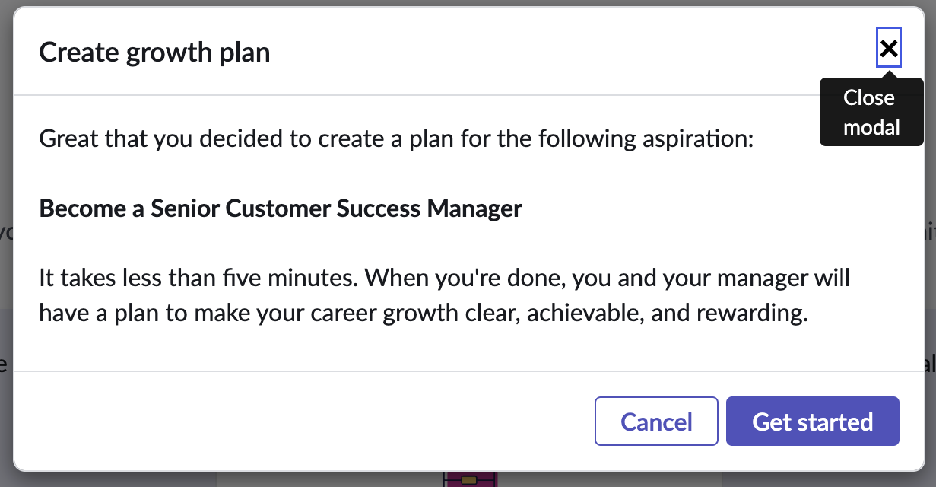
- Skill based Aspiration Creation
- Follow steps 1-5 in the flow above (Section 1) to start the aspiration creation flow.
- Choose “Mastering a skill” and click next.

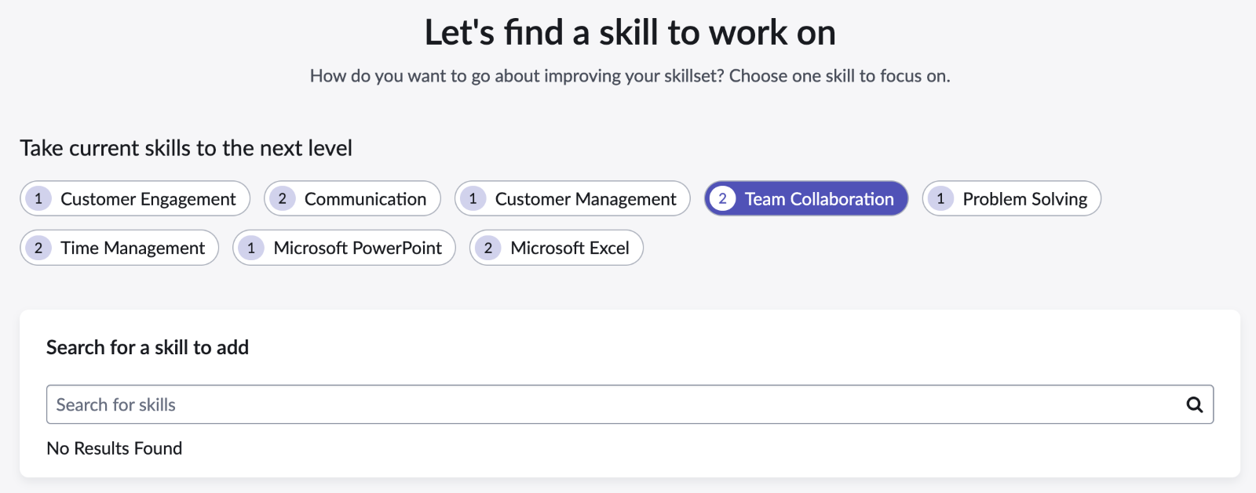

- This flow is very similar to the role based aspiration flow, except that the employee is choosing a skill to base this aspiration off of. Currently you’re limited to one skill per asp.iration.
- Pick Team collaboration as this skill should support the role based aspiration created in step 1.0 earlier. The search works the same way that it does for roles, except that is searches other skills to base the aspiration from.
- Click Next. This opens the details screen. Fill out details using the same steps as step 10 above.
- Click Next. This opens the final settings screen. Choose the following values.
- Who can see this aspiration: You and your manager
- Do you want to send a notification to them: No

Click Submit. The skill based aspiration is complete.

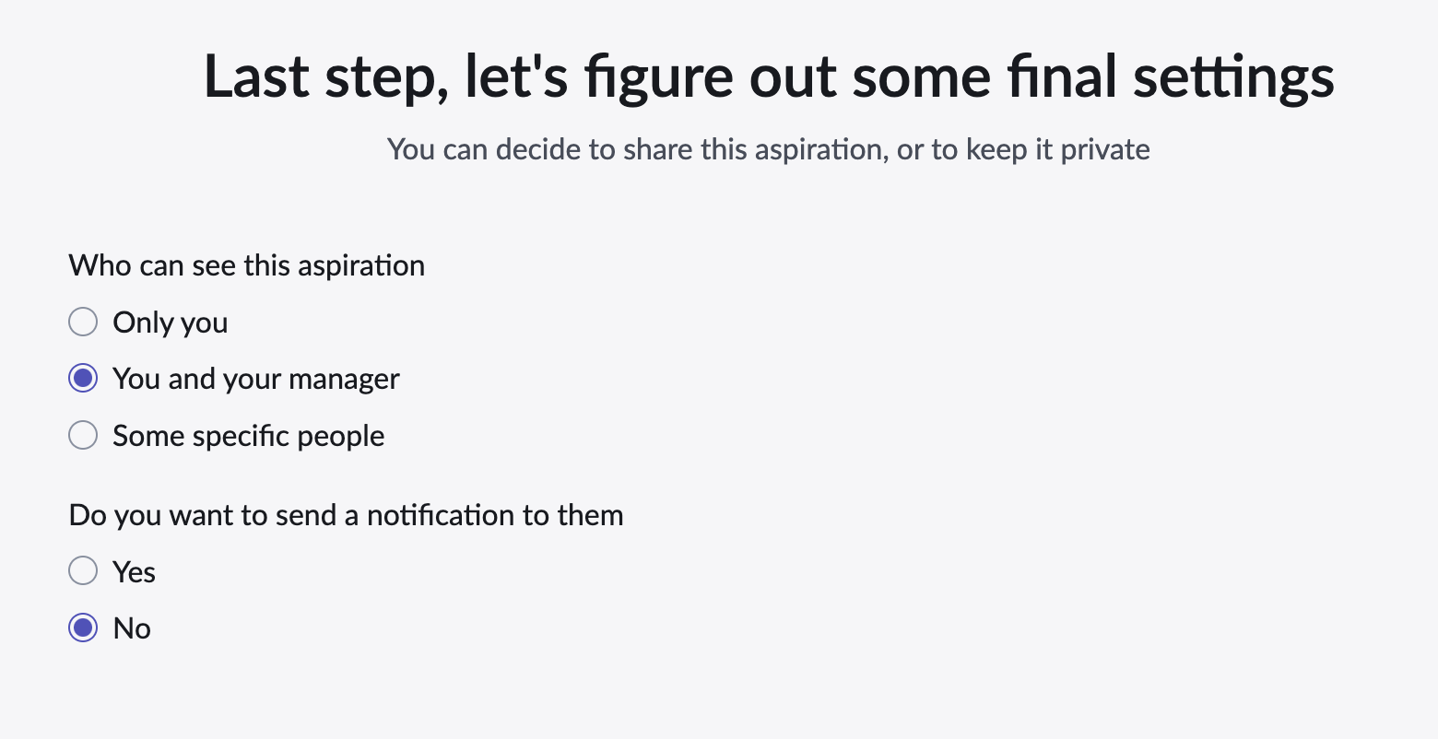

On the completion screen, click View all your aspirations to go back to the aspiration homepage.

- Interest Based Aspiration Creation
Note: Interest aspirations link to one of the records in the interest table. Aside from this difference interest-based aspirations are identical to something else aspirations. Something else is basically a catch all, generic aspiration, so this guide only covers interest since they are similar.

- Follow steps 1-5 in the 1.0 flow above to start the aspiration creation flow.
- Choose Exploring an interest area and click Next.

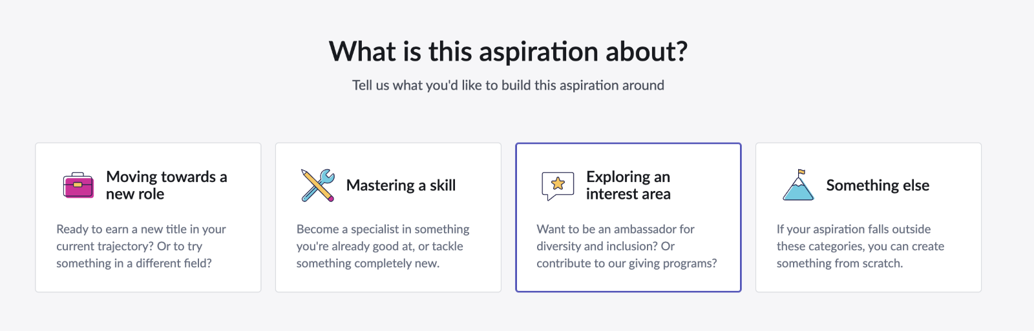

- A card represents each interest in the interest table. Click the first one – Helping others in our community – which should be the interest you created in the admin lab. Click Next.

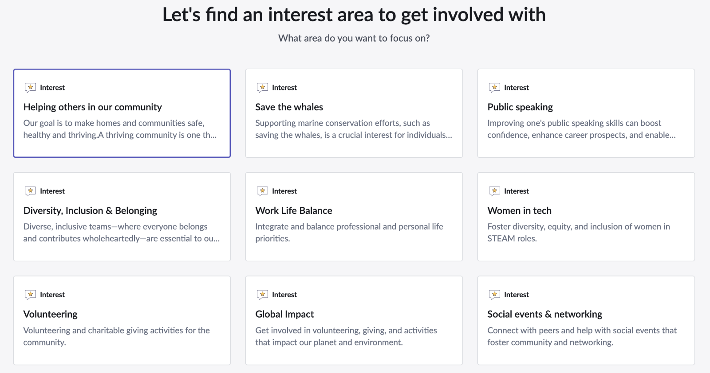

- Fill out details with any values you wish.

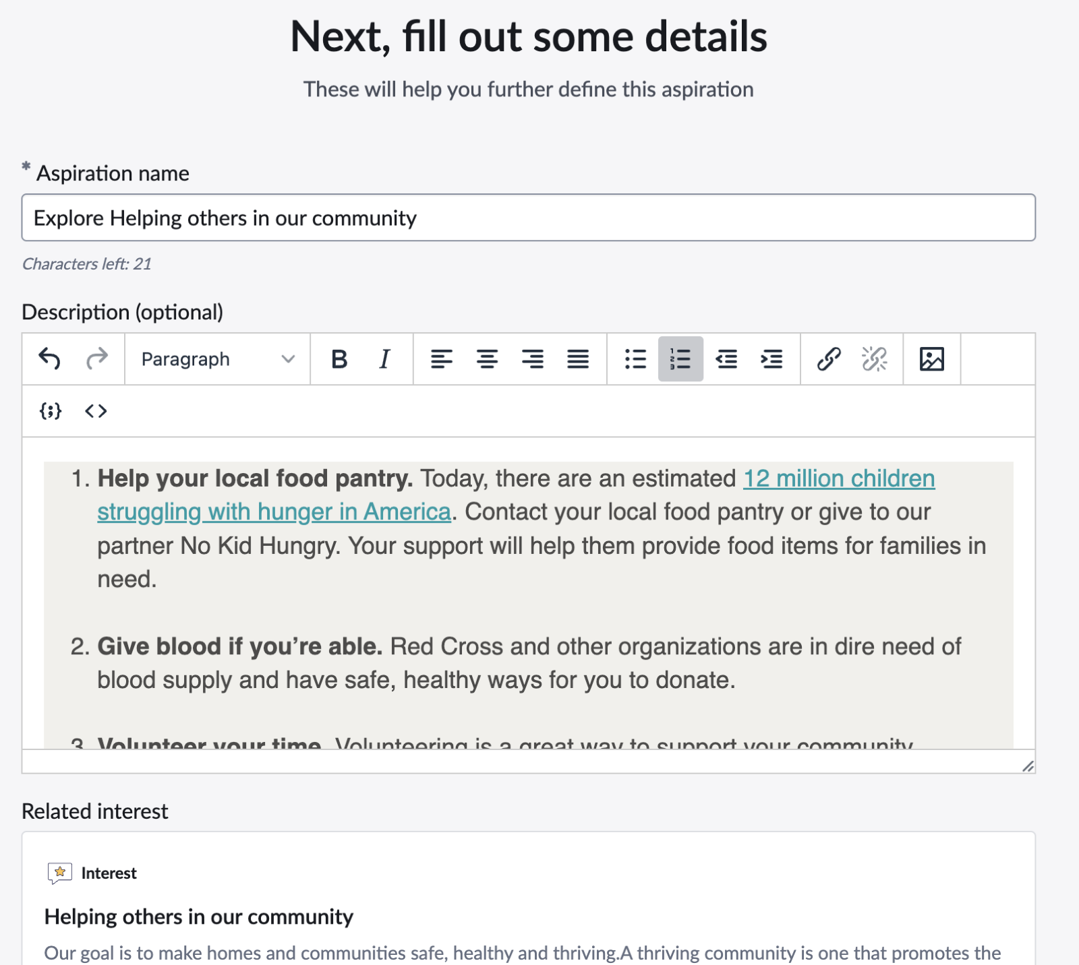

- Click Next which opens the last step in the flow. In this case, keep the aspiration to Only you.

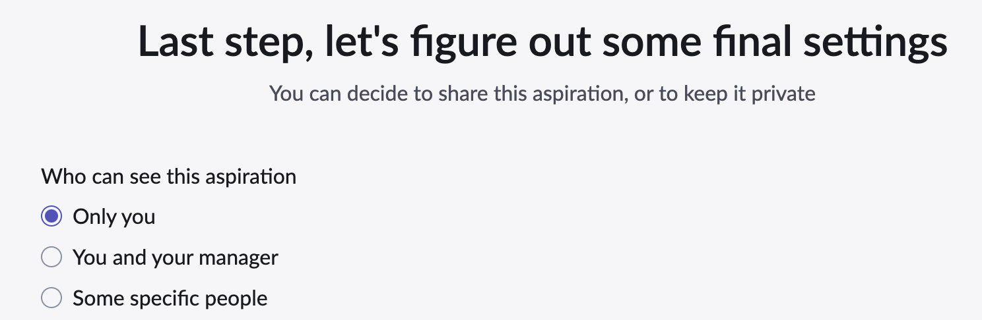

- Click Submit to complete the aspiration.
- Click View all your aspirations to go back to the main Aspirations page.

- Aspiration Modification
Note: This step covers all flows to modify an aspiration

- Follow steps 1-4 in the 1.0 flow above to start the Aspiration Home Page.
- Scroll down to Your aspirations where each aspiration is summarize

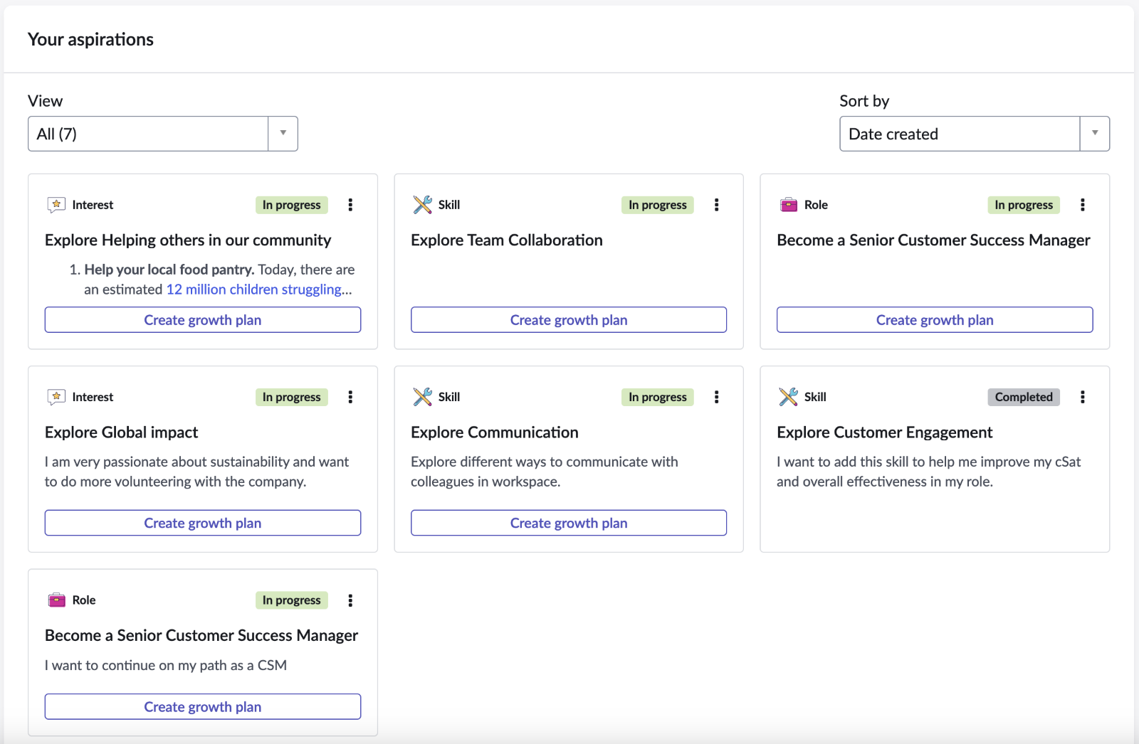

- Locate one of the aspirations you created earlier. Click on the kebab icon in the upper right to open options.

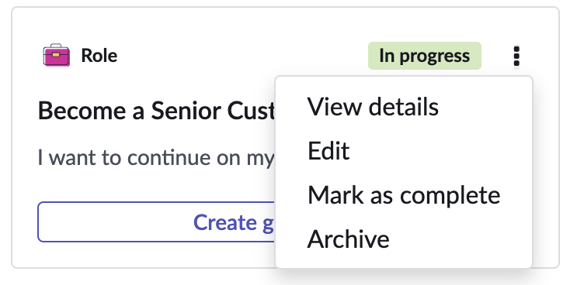

- Click View details. This opens a flyout with all the information in the aspiration.

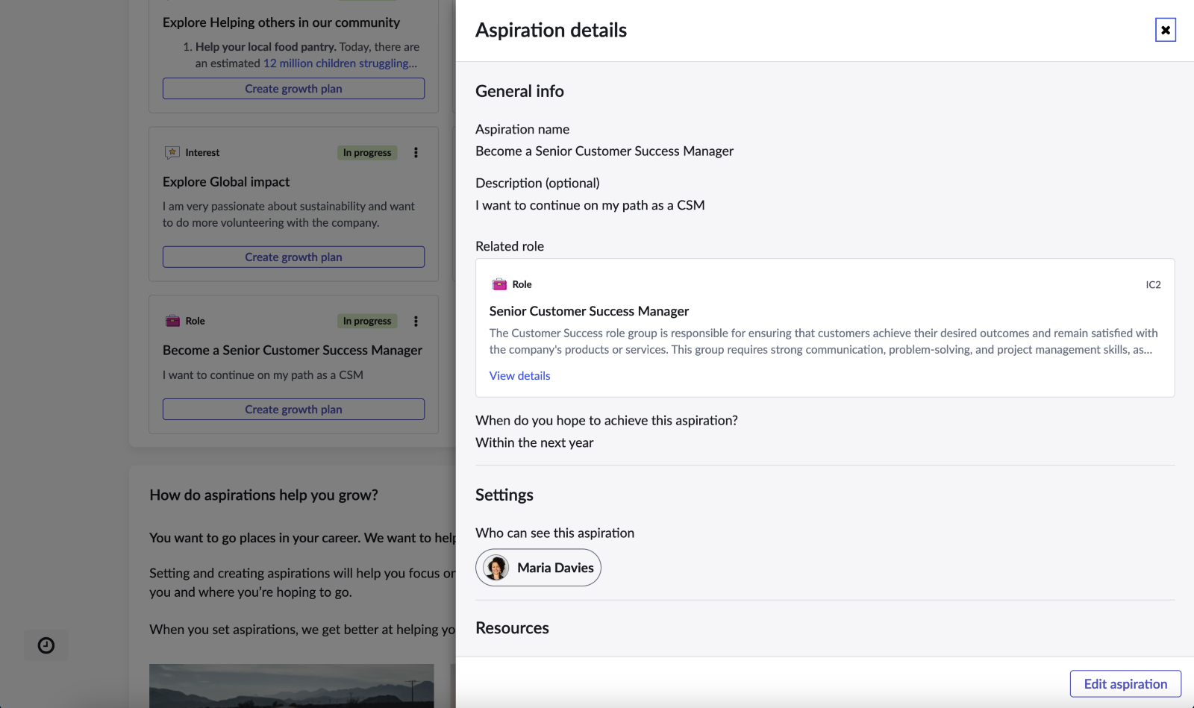

- You can review all aspects of the aspiration as well as viewing additional details on it.
- Click the Edit aspiration button. This makes the form updatable and note that the kebab option for edit does the same thing.
- Update the When do you hope to achieve this aspiration to Within the next year.
- Scroll down and note that you can access the growth plan that the aspiration is linked to.
- Click Save and close. This updates the aspiration with any new values.
- Choose archive from the kebab menu. This marks the aspiration as Archived.

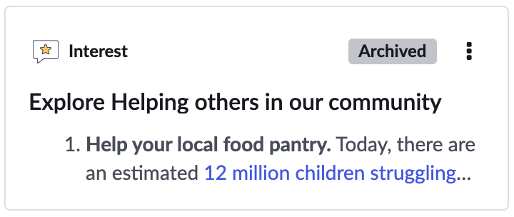

- When archived the aspiration is basically on hold and the kebab menu provides different options.

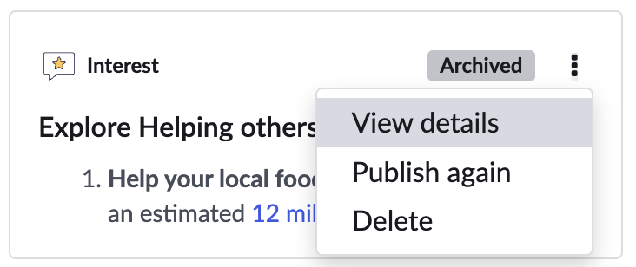

- Click Publish again to put it back into In progress state.
- Time has passed and Emily feels she has aspired to her aspiration. Choose the complete option to mark the aspiration as Completed.

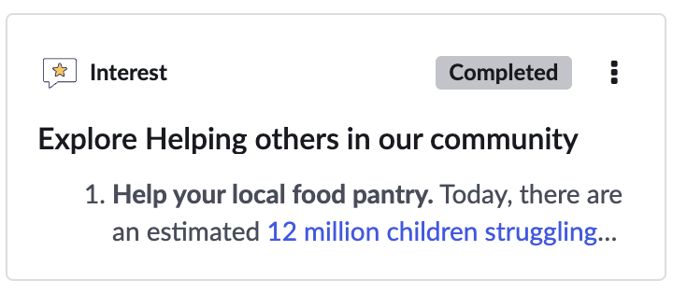

- Manager Specific Flow: Employee Profile
Managers can create aspirations and share them with their managers just like employees. Where the manager use case differs, is that managers have access to Manager Hub along with all their direct report employee profiles where they can view a direct reports aspiration.
- Impersonate Maria Davies, Emily’s manager.
- Navigate to Employee Center.
- Choose Your team from the menu, click on Team members option.

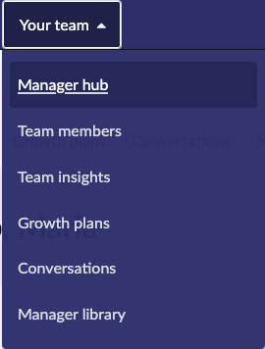

- Scroll down the page and find Emily’s record. Click on the kebab menu to the right, and choose View Profile

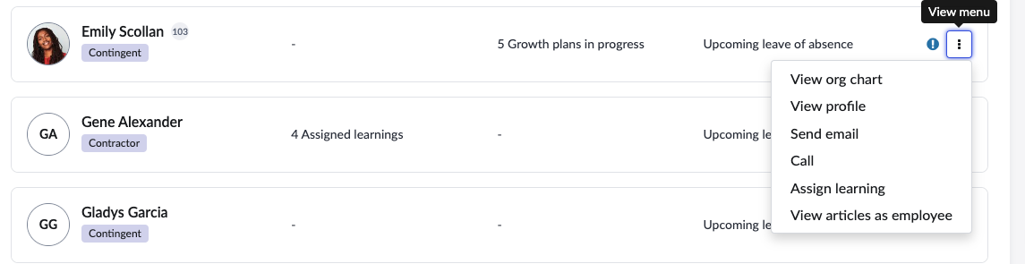
- Click on the career tab.

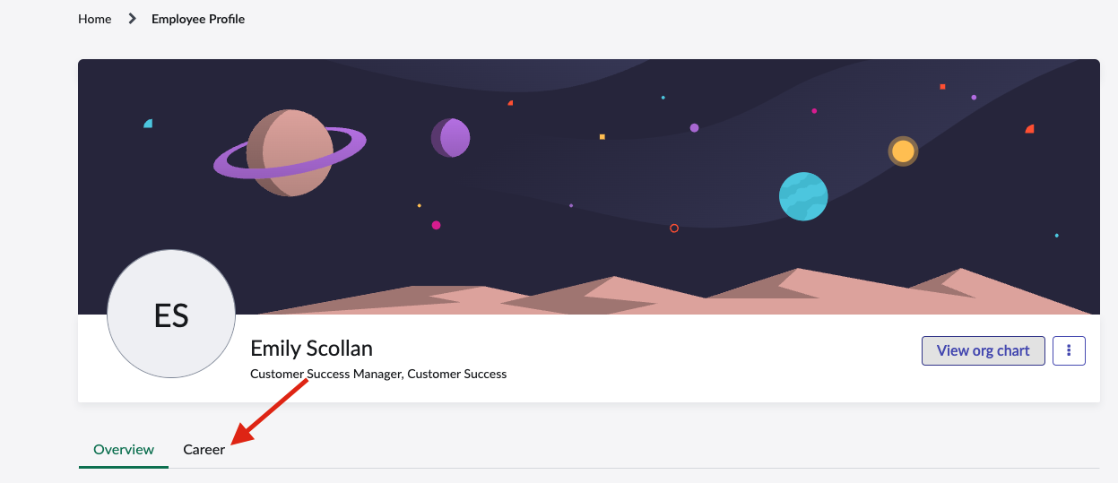

- You can now view the Aspirations widget showing all aspirations that Emily has shared with her manager Maria.

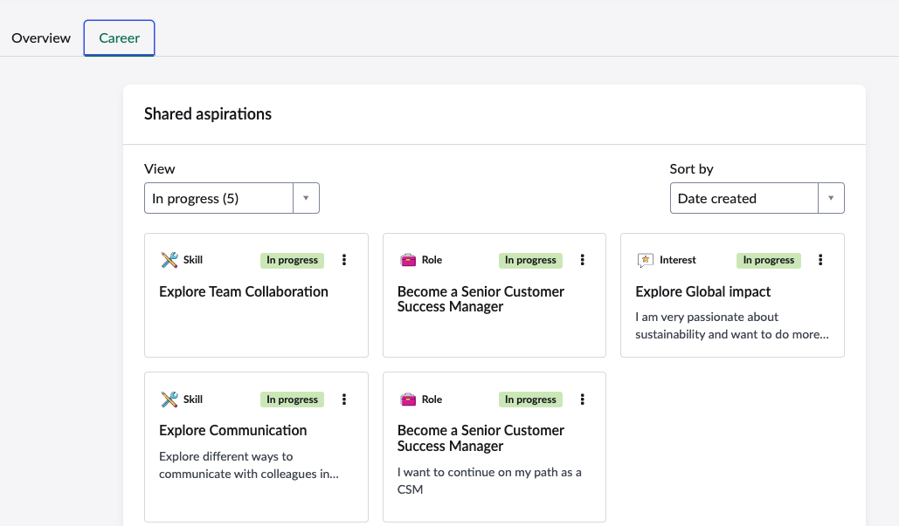

- Manager Specific Flow: Conversations App
Managers can also view their employees’ current aspirations in the
Conversations app during a growth conversation. Conversations can be
accessed through manager hub as well as the Conversations app.

- Impersonate Maria Davies, Emily’s manager.
- Navigate to Employee Center.
- Choose Your team from the menu, click on Conversations option.

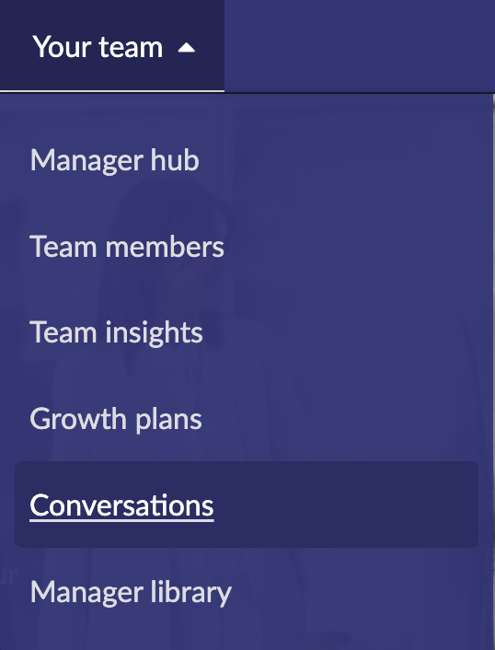

- Click on the Add talking points button in any of the Emily Scolan conversations in the Coming up Soon widget.

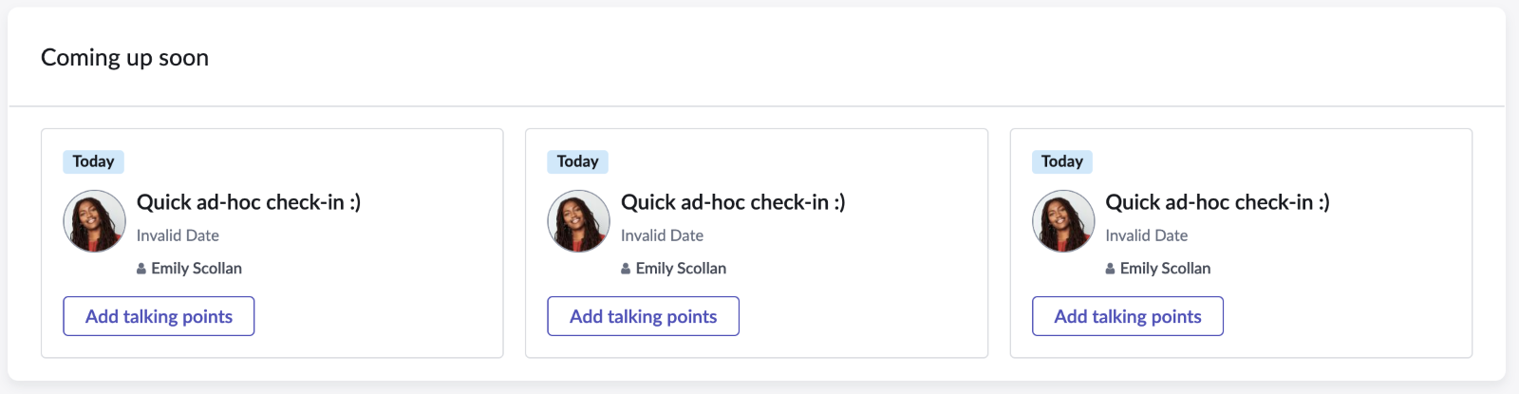

- When the Conversations app opens, Scroll down and note that you can see all of an employee’s aspirations in the sidebar.

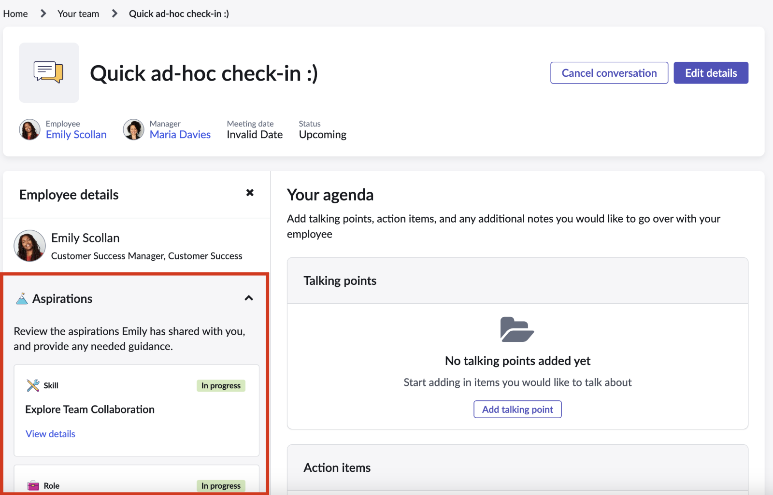

- Click on one of the Aspirations to open it in the Aspirations app.

