This article came from a question from the audience, and while researching I found an excellent community post written by Pratiksha. In the end, I saw that this is currently what is in the docs.Pratiksha
Understanding CI Reclassification: What You Need to Know
Understanding CI Reclassification: What You Need to Know In the world of IT Service Management, Configuration Items…www.servicenow.com
At the end of the day, what I did was a literal translation with images
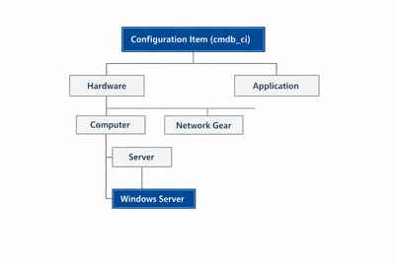
Understanding Configuration Item (CI) Reclassification:
What You Need to Know?
In the world of IT Service Management, Configuration Items (CIs) play a crucial role in tracking and managing the components of your IT environment. Sometimes, it may be necessary to reclassify a CI to better reflect its role or characteristics. Reclassification involves changing a CI’s class, which impacts how its attributes are managed and which data can be retained or lost. Let’s break down the reclassification process and explore examples to illustrate how it works.
What Happens During CI Reclassification?
When a CI is reclassified, the following key events occur:
Attribute adjustment: The CI’s attributes are updated to match those of the new class. This means some attributes may be added, while others may be removed.
Loss of unique attributes: If the new class does not include attributes that were present in the current class, those attributes and their values will be lost.
Creation of a new record: A new record is created in the new class for the CI, but the CI keeps its unique identifier (sys_id).
Types of Reclassification
There are three main types of reclassification: downgrade, upgrade, and switch. Each type affects the CI differently.
Downgrade
Definition: A downgrade involves moving a CI to a higher-level class in the hierarchy. This means the CI is reclassified into a more general category.
Example: Suppose you have a CI classified as cmdb_ci_server, which is a specific type of server.
If you reclassify this CI to cmdb_ci_computer, a more general category, you are performing a downgrade.
Impact: The cmdb_ci_server class may have attributes such as RAM, CPU speed, and hard drive size that are not available in the cmdb_ci_computer class. During the downgrade, these specific attributes will be lost because the new class does not support them.
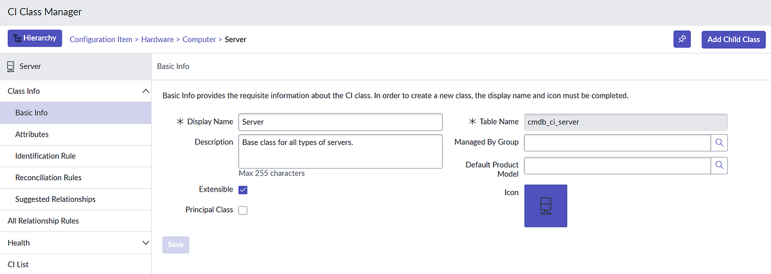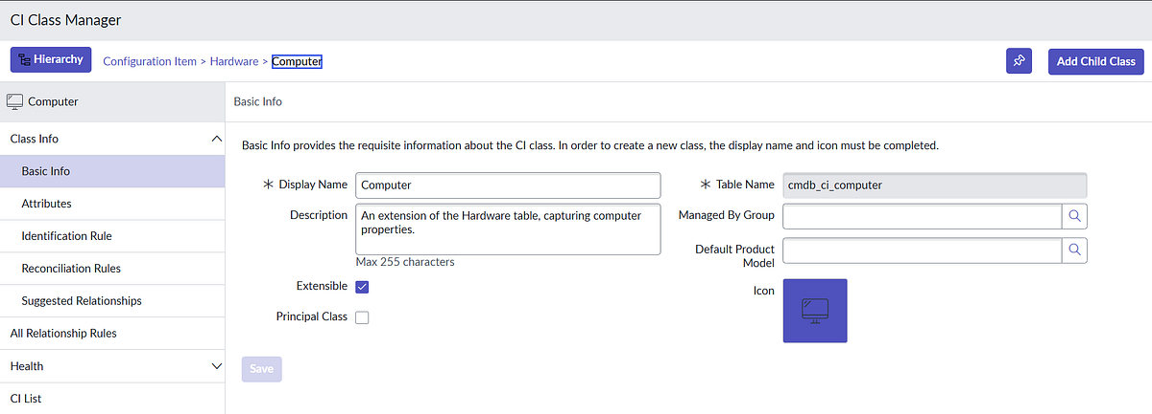
Upgrade
Definition: An upgrade involves moving a CI to a lower-level class in the hierarchy. This means the CI is reclassified into a more specific category with additional attributes.
Example: Imagine you have a CI classified as cmdb_ci_computer.
If you reclassify this CI to cmdb_ci_server, a more specific category, you are performing an upgrade.
Impact: The cmdb_ci_computer class may have general attributes, but the cmdb_ci_server class includes more specific attributes, such as Server Type and Operating System. In this case, the CI will gain these additional attributes during the upgrade.
Switch
Definition: A switch involves moving a CI to a class in a completely different branch of the hierarchy. This is a combination of downgrade and upgrade.
Example: Suppose you reclassify a CI from cmdb_ci_linux_server to cmdb_ci_win_server. Here, you are switching between classes in different branches (Linux servers to Windows servers).
Impact: This switch involves a downgrade (loss of Linux-specific attributes) and an upgrade (gain of Windows-specific attributes). Attributes unique to the cmdb_ci_linux_server class, such as Linux Distribution, will be lost, while new attributes related to the cmdb_ci_win_server class, such as Windows Version, will be added.
Important Considerations
Data loss: Downgrades and switches can result in the loss of valuable data. It is important to carefully plan and review the impact of reclassification to avoid accidental data loss.
Automatic reclassification: Many systems have automatic Configuration Item (CI) reclassification enabled by default.
This feature can automatically adjust CIs based on changes, which can also lead to data loss if not properly managed. It is crucial to understand how your system’s Identification and Reconciliation Engine (IRE) handles these processes and to adjust settings as needed.
Procedure (docs)
- Locate the CI that you want to reclassify and display it in a list view.
Locate the CI you want to reclassify and display it in a list.
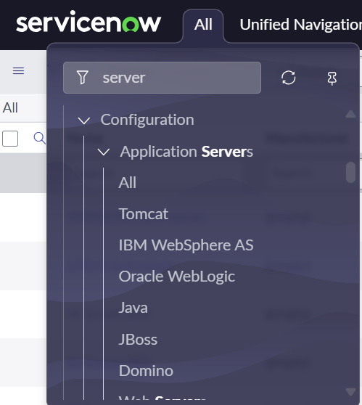
2. You can use the application navigator. Or, for example, if the CI is a server, type cmdb_ci_server.list in the navigation search box to display the CI in the Servers view.
You can use the application navigator. Or, for example, if the CI is a server, type cmdb_ci_server.list in the navigation search box to display the CI in the Servers view.
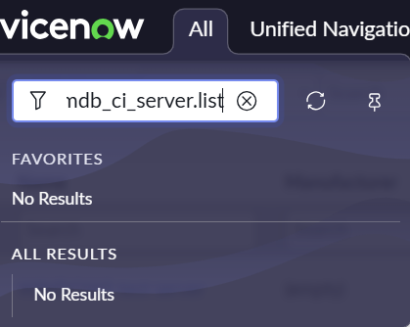
3. Ensure that the Class field is displayed in the list.
Make sure the “Class” field is visible in the list.
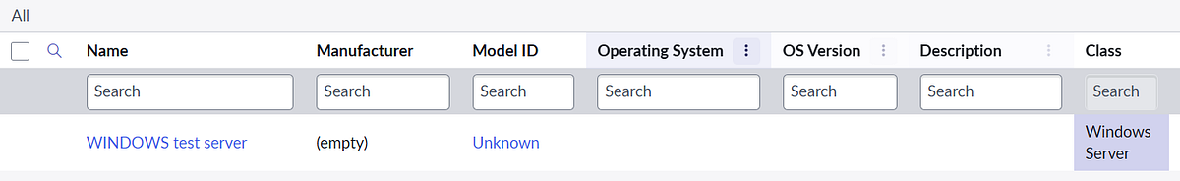
4. If you do not see this attribute, personalize the list to add the Class field.
If you do not see this attribute, personalize the list to add the Class field.
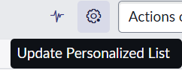
5. Double-click the CI’s Class value and select a new class.
Double-click the “Class” value for the CI and select a new class.
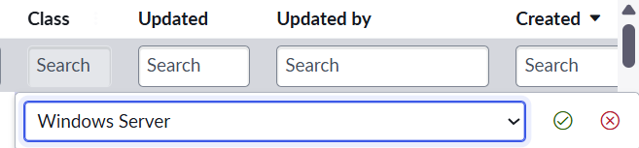
6. Click the green check box to confirm your selection.
Click the green check box to confirm your selection.

Conclusion
CI reclassification is a powerful tool for keeping data accurate and relevant in your IT environment. By understanding the differences between downgrades, upgrades, and switches, and by being mindful of the potential for data loss, you can better manage the lifecycle of your CIs and ensure that your configuration management remains effective and efficient. Always review the attributes of the current and new classes, and consider the implications of automatic reclassification to avoid surprises.
- https://www.servicenow.com/docs/r/yokohama/servicenow-platform/configuration-management-database-cmdb/t_ManuallyReclassifyCI.html
- https://www.servicenow.com/community/cmdb-forum/ci-reclassification-explained-what-we-should-know/m-p/3448236
- https://www.servicenow.com/community/developer-forum/example-for-ci-upgrade-downgrade-switch-in-cmdb/m-p/1400036#:~:text=Reclassify%20a%20CI%20by%20modifying%20its%20%27Class%27%20attribute.,in%20the%20newly%20reclassified%20class%20-%20are%20lost.
- https://www.servicenow.com/community/virtual-agent-forum/task-10-configure-reclassification-system-property/m-p/2755462
- A Deep Dive into CI Class Manager and IRE Servicenow CMDBA Deep Dive into CI Class Manager and IRE ServiceNow CMDB. PrathmeshdaPrathmeshda

